**H. Geometry Section 3.1 Notes Cont… Date: _________**

Now that we have learned the names and relationships of angles formed by intersecting or parallel lines, we will use that to solve equations. It may help to identify the type of angle first, so you know whether they are ______________ or _____________________ angles.

Example 1: Find the value of x in the diagram below.

x = _______

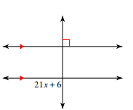

Example 2: Find the value of x in the diagram below.

x = _______

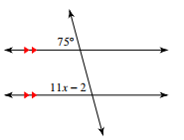

Example 3: Find the value of x in the diagram below.

x = _______

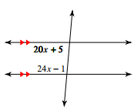

**Identify each angle pair from the diagram at the right. (Use this diagram for #1-10.)**

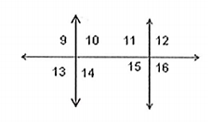1. 9 and 10 _________________________________

2. 12 and 13 _________________________________

3. 9 and 12 _________________________________

4. 11 and 16 _________________________________

5. 14 and 11 _________________________________

6. 10 and 12 _________________________________

7. 14 and 15

Using the diagram above, if , find the angle measures below.

8.  because

9.  because

10. because

**Use the diagram at the right for questions 11 and 12.**

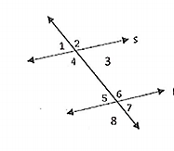

11. Assume . Solve for x if  and .

12. Assume . Solve for x if  and .

