**Graph each inequality.**

1.) G < 5 2.) – 7 w

**Write an inequality for each statement.**

3.) Michael needs at least 10 points to win the game. 4.) The minimum height to get into the ride is 48 inches.

5.) The van can hold no more than 8 passengers. 6.) Amani can invite up to 30 people to her birthday party.

7.) Write an inequality for the following graph.

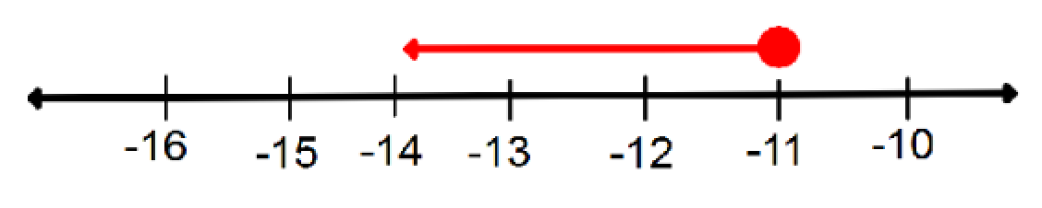

**Algebra I – Bellwork #31 Date: __________**

**Graph each inequality.**

1.) G < 5 2.) – 7 $≤$ w

**Write an inequality for each statement.**

3.) Michael needs at least 10 points to win the game. 4.) The minimum height to get into the ride is 48 inches.

5.) The van can hold no more than 8 passengers. 6.) Amani can invite up to 30 people to her birthday party.

7.) Write an inequality for the following graph.

