1.) The perimeter of a triangle is 57 ft. Two sides have equal lengths. The sides with equal lengths are four less than twice the third side. Write and solve an equation to find the lengths of the three sides.

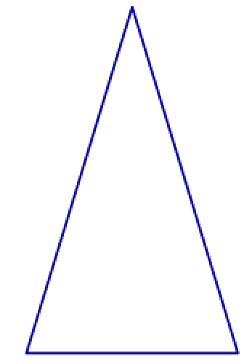

2.) Solve this equation for W.

$$G=M∙ \frac{W+R}{K}-C$$

3.) The perimeter of a rectangle is 56 cm. The length is 5 less than twice the width. Find the dimensions of the rectangle.

**Algebra I – Bellwork #26 Date: __________**

1.) The perimeter of a triangle is 57 ft. Two sides have equal lengths. The sides with equal lengths are four less than twice the third side. Write and solve an equation to find the lengths of the three sides.



2.) Solve this equation for W.

3.) The perimeter of a rectangle is 56 cm. The length is 5 less than twice the width. Find the dimensions of the rectangle.