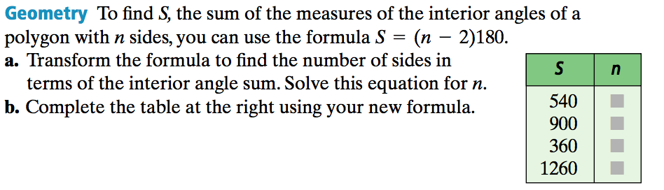

1.)

PSAT Practice –

2.) For what value of $h$ is $24=\frac{h}{10}-6?$ 3.) What is the value of $a$ if $\left(2a+3\right)-\left(4a-8\right)= 7?$

**Algebra I – Bellwork #25 Date: __________**



1.)

PSAT Practice –

2.) For what value of $h$ is $24=\frac{h}{10}-6?$ 3.) What is the value of $a$ if $\left(2a+3\right)-\left(4a-8\right)= 7?$