1.) 2.) Which of the following is equivalent to $\left(s-t\right)\left(\frac{s}{t}\right)?$

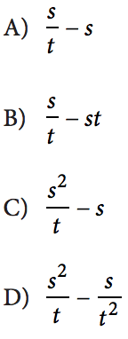If $(x, y)$ is a solution to the equation above and

$y≠0$, what is the ratio of $\frac{x}{y}?$

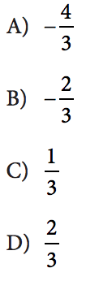

3.) If $x$ is not equal to zero, what is the value of

of $\frac{4{\left(3x\right)}^{2}}{(2{x)}^{2}}?$

**Algebra I – Bellwork #23 Date: _______**

1.) $3\left(x+y\right)=y$ 2.) Which of the following is equivalent to $\left(s-t\right)\left(\frac{s}{t}\right)?$

If $(x, y)$ is a solution to the equation above and

$y≠0$, what is the ratio of $\frac{x}{y}?$



3.) If $x$ is not equal to zero, what is the value of

of