Section 2.1 – 2.3 Quiz Review:

*One-Step, Two-Step, Multi-Step Equations*

Solve each equation. Round any decimal answers to the nearest tenth or leave as a fraction.

***\*\*Skip #15–17\*\****

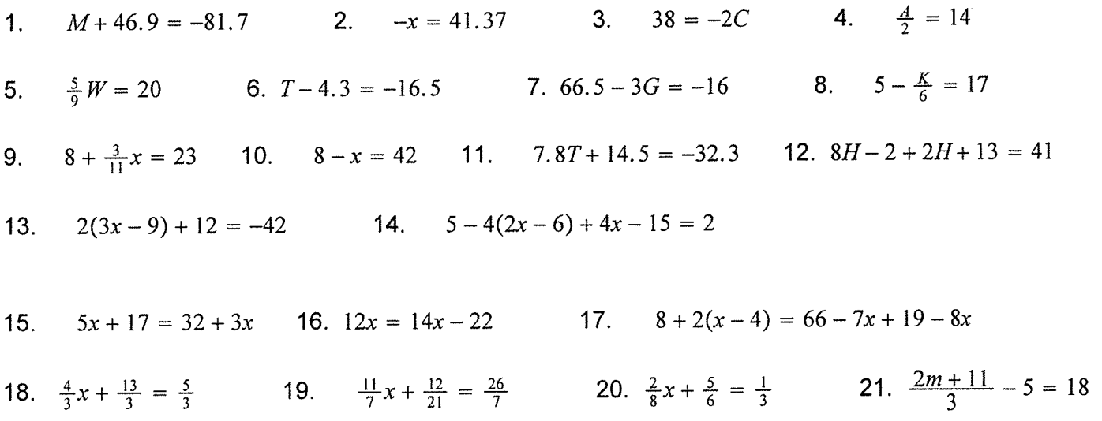

ANSWERS:

