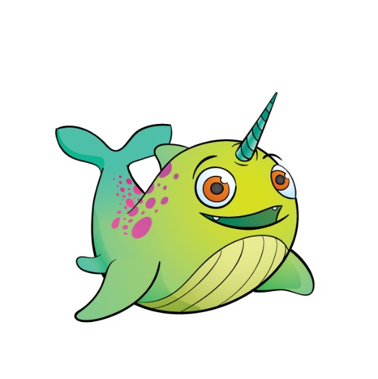
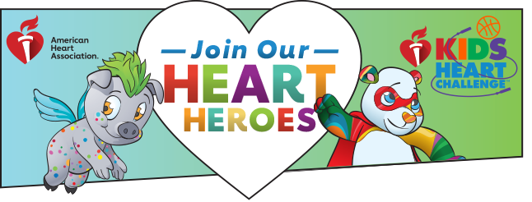
Splash’s message is avoid sugary beverages!
Our school is proud to partner with the American Heart Association again this year! Last year, we participated in Jump Rope For Heart and this year we’re kicking off Kids Heart Challenge! We’re excited to continue JUMPING ROPE to help those with special hearts!

It’s easy to help your student earn Splash and take the challenge. To get started visit our school’s website

http://www2.heart.org/site/TR?company_id=163478&fr_id=3998&pg=company
PLUS! CLASSROOM THAT RAISES THE MOST $ WILL EARN EXTRA PE TIME
Double your donations! Visit www.matchinggifts.com/aha to see if your company matches.

