WHaG **White Man’s Burden: 19th Century Imperialism** Name:

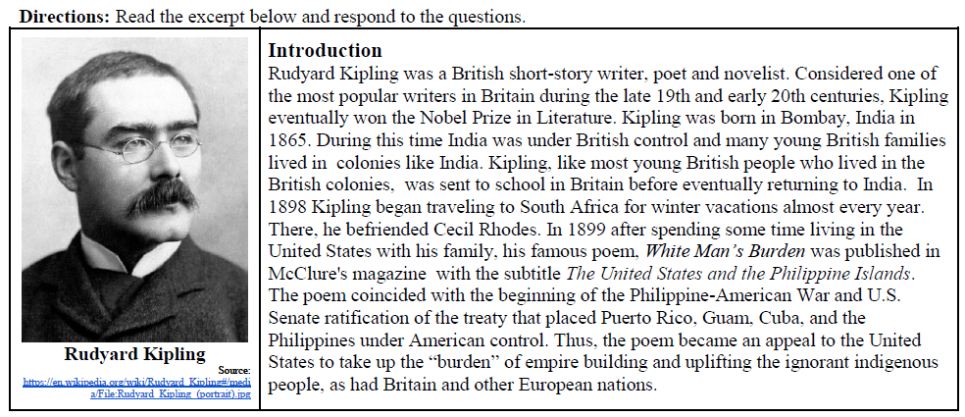

1. Who wrote *White Man’s Burden*? 2. When was it written?

3. Where was it written? 4. Is White Man’s Burden a primary or secondary source?

5. What genre (letter, memoir, journal, edict, etc.) of document is *White Man’s Burden*? What does this reveal about the intended impact of this document?

6. What was the author’s message or goal with *White Man’s Burden*?

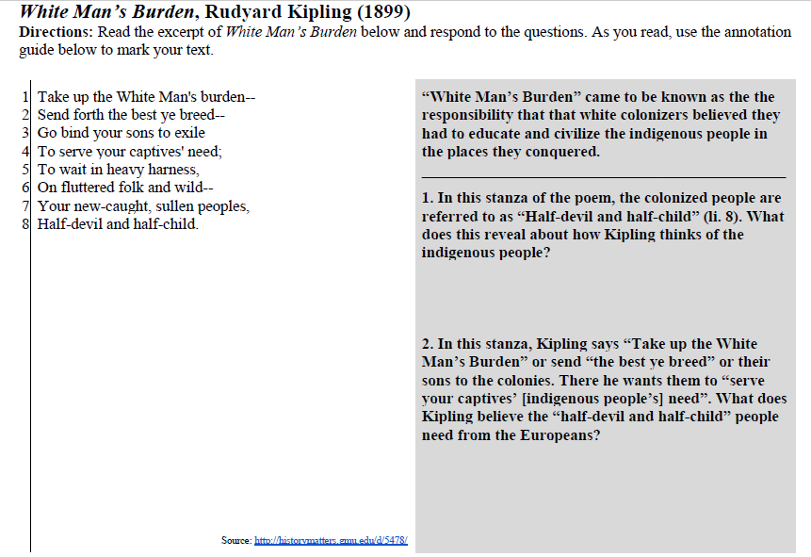

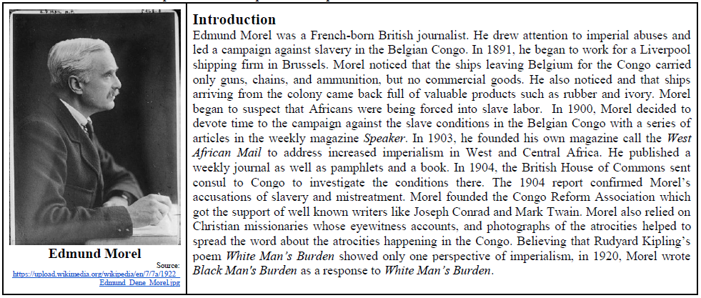

1. Why did Edmund Morel suspect that Africans were being forced into slavery?

Read the excerpt of *Black Man’s Burden* and respond to the questions.

