Wld. Hist. 9 British Child Labor: 1800s

Elizabeth Bentley, interviewed by Michael Sadler's Parliamentary Committee on 4th June, 1832.
I worked from five in the morning till nine at night. I lived two miles from the mill. We had no clock. If I had been too late at the mill, I would have been quartered. I mean that if I had been a quarter of an hour too late, a half an hour would have been taken off. I only got a penny an hour, and they would have taken a halfpenny.

Frank Forrest, Chapters in the Life of a Dundee Factory Boy (1850)
In reality there were no regular hours, masters and managers did with us as they liked. The clocks in the factories were often put forward in the morning and back at night. Though this was known amongst the hands, we were afraid to speak, and a workman then was afraid to carry a watch.

The youngest children in the textile factories were usually employed as scavengers and piecers. Piecers had to lean over the spinning-machine to repair the broken threads. Scavengers had to pick up the loose cotton from under the machinery. This was extremely dangerous as the children were expected to carry out the task while the machine was still working.
Frances Trollope, Michael Armstrong, the Factory Boy(1840)
A little girl about seven years old, who job as scavenger, was to collect incessantly from the factory floor, the flying fragments of cotton that might impede the work... while the hissing machinery passed over her, and when this is skillfully done, and the head, body, and the outstretched limbs carefully glued to the floor, the steady moving, but threatening mass, may pass and repass over the dizzy head and trembling body without touching it. But accidents frequently occur; and many are the flaxen locks, rudely torn from infant heads, in the process.

John Fielden, speech in the House of Commons (9th May 1836)
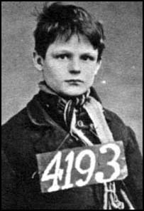
At a meeting in Manchester a man claimed that a child in one mill walked twenty-four miles a day. I was surprised by this statement, therefore, when I went home, I went into my own factory, and with a clock before me, I watched a child at work, and having watched her for some time, I then calculated the distance she had to go in a day, and to my surprise, I found it nothing short of twenty miles.

Children who worked long hours in the textile mills became very tired and found it difficult to maintain the speed required by the overlookers. Children were usually hit with a strap to make them work faster. In some factories children were dipped head first into the water cistern if they became drowsy. Children were also punished for arriving late for work and for talking to the other children. Parish apprentices who ran away from the factory was in danger of being sent to prison. Children who were considered potential runaways were placed in irons.

Jonathan Downe was interviewed by Michael Sadler's Parliamentary Committee on 6th June, 1832.
When I was seven years old I went to work at Mr. Marshalls factory at Shrewsbury. If a child was drowsy, the overlooker touches the child on the shoulder and says, "Come here". In a corner of the room there is an iron cistern filled with water. He takes the boy by the legs and dips him in the cistern, and sends him back to work.

John Allett started working in a textile factory when he was fourteen years old. Allett was fifty-three when he was interviewed by Michael Sadler and his House of Commons Committee on 21st May, 1832.
Question: Do more accidents take place at the latter end of the day?
Answer: I have known more accidents at the beginning of the day than at the later part. I was an eye-witness of one. A child was working wool, that is, to prepare the wool for the machine; but the strap caught him, as he was hardly awake, and it carried him into the machinery; and we found one limb in one place, one in another, and he was cut to bits; his whole body went in, and was mangled.

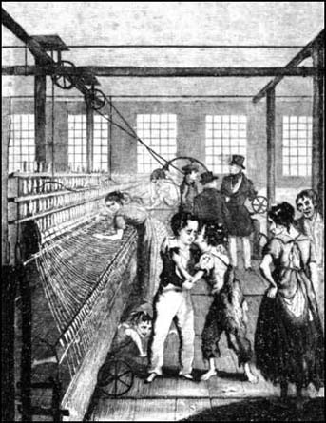
A report commissioned by the House of Commons in 1832 said that: "there are factories, no means few in number, nor confined to the smaller mills, in which serious accidents are continually occurring, and in which, notwithstanding, dangerous parts of the machinery are allowed to remain unfenced."
The report added that he workers were often "abandoned from the moment that an accident occurs; their wages are stopped, no medical attendance is provided, and whatever the extent of the injury, no compensation is afforded."

http://www.spartacus.schoolnet.co.uk/IRchild.main.htm

