Name: ____________________________________ Hour: 1st 2nd 6th **Unit Test Study Guide**

|  |
| --- |
| **Concept Overview: Main Ideas & Standards**  *MS-LS1-6:* Trace the movement of matter and flow of energy through an ecosystem  *MS-LS1-7:* Molecules from food/glucose are broken apart and the pieces are used to create waste. Energy released in the reaction is used to fuel the body.  *MS-LS2-3:* Create and use models to show the flow of energy in an ecosystem.  *MS-LS2-4:* Recognize patterns in models and predict how changes to the pattern will affect the ecosystem.  **What to Expect on the Test**   * *Vocabulary section:* Some selected vocabulary words from each section are arranged on a crossword puzzle. Use the clues to place the words into the crossword.      * *Multiple choice:*  Questions are given with options for answers. Write the answer in the blank. * *Matching:* A range of descriptions match up to a list of words. Use each word once only. * *Short answer:* Questions are to be answered in complete sentences. Restate the question to help you start your answer. Make sure you answer all parts of the question. |

**Concepts: Photosynthesis & Cellular Respiration**

**Recall** the photosynthesis equation below:

___________ + ____________ + ________________ → ____________ + ________________

**Recall** the cellular respiration equation below:

___________ + ____________ → ________________ + ____________ + ________________

**Identify** each of the following symbols and/or chemical formulas used in our equations.

CO2 = ___________________________ O2 = ________________ H2O = ___________________

C6H12O6 = _____________________________ → = _______________________________

**Concept: Food Webs & Energy Flow in Ecosystems**

**Identify:** Where does all energy from the ecosystem originally come from? _____________________

**Extend:** How does the energy flow through the ecosystem after that? _________________________

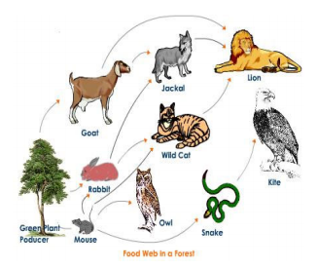

**Predict:** In this food web, describe in complete sentences **3 things** that might happen as a result of the lion disappearing from this ecosystem.

* 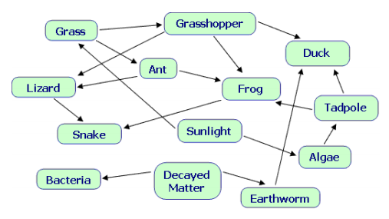

**Identify:** The predator of the frog is: ___________  
  
**Describe:** How would the snake be affected if the sun were blocked out for an extended time?  
  
  
  
  
**Use the table below to create a small food web.**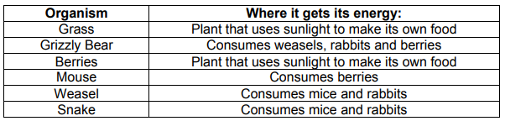

Drawings are optional in this model.