Academic Vocabulary Study Guide #8

Topic

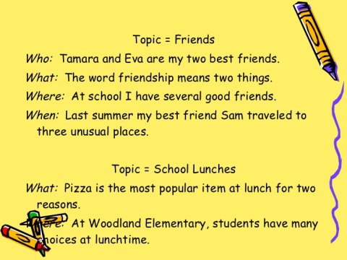

A topic is what the article, passage, or story is about.

Specific words

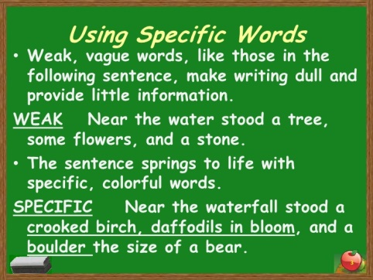

Specific words are very descriptive, so the reader knows exactly what the author is trying to say.

Purpose for writing

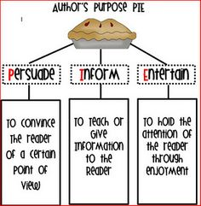

The purpose for writing is to persuade, inform, or entertain.

Mental picture

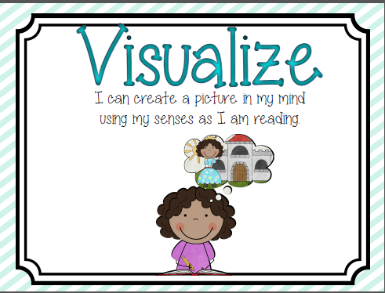

A mental picture is what you can visualize in your mind while reading.

Grammar Usage

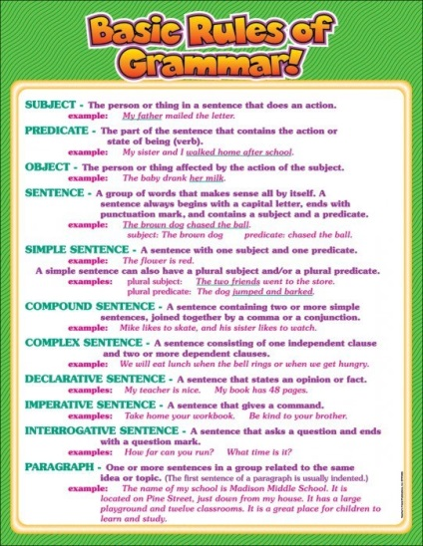

Grammar usage refers to how well someone writes complete sentences.

Verb Tense

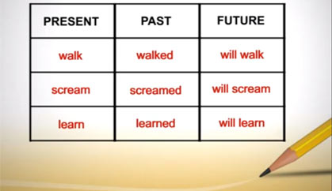

Verb tense are action words in the past, present, and future.