Graphic Organizer

The U.S. Constitution
Need for Government

Why do we need government?
What would life be like without rules or laws?

Purposes of Government

Listed in the Preamble

Big Ideas Card

Big Ideas of Lesson 1, Unit 5
- Political scientists ask questions about what governments do, how governments are organized, the values and principles connected to government, and the role of citizens in government.
- There would be many serious consequences if schools, communities, and our country tried to function without government and rules or laws.
- People institute governments for many reasons such as safety, promoting the common good, and protecting individual rights.
- The Preamble to the U.S. Constitution describes the purposes of our federal government.

Word Cards

1  government  a system people use to exercise authority, distribute power, and regulate conduct of people  Example: Cities, states, and countries all have a government.  (SS040501) | 2  federal government  the government of our country  Example: Our federal government is centered in Washington, D.C.  (SS040501)
3  Constitution  the written document that created the system of government for our country  Example: Our Constitution describes the power and organization of our government.  (SS040501) | 4  Preamble  the introduction to our Constitution  Example: Our Constitution begins with a Preamble which explains the purposes of our federal government.  (SS040501)

Connecting Back

Big Ideas of Lesson 4, Unit 1
- Government is a system people use to exercise authority, distribute power, and regulate conduct of people.
- Civics is the study of the rights and duties of citizens.
- Political scientists study government and how people interact with them (civics).
- Political scientists ask questions about what governments do, how governments are organized, the values and principles connected to government, and the role of citizens in government.

Questions
Political Scientists Ask

How is the government organized?

On what values and principles is the government based?

Why is government needed?

What does government do?

What role do citizens play?
Life Without Government or Rules/Laws
Small Group Activity Sheet

 | What Would Life Be like? | What Problems Would Be Likely to Happen?
School

(Think about life in the lunchroom, playground, and hallways)
Community

(Think about life in shopping centers, neighborhoods, and at traffic intersections)
Country

(Think about how people in one state might treat someone from another state or country)

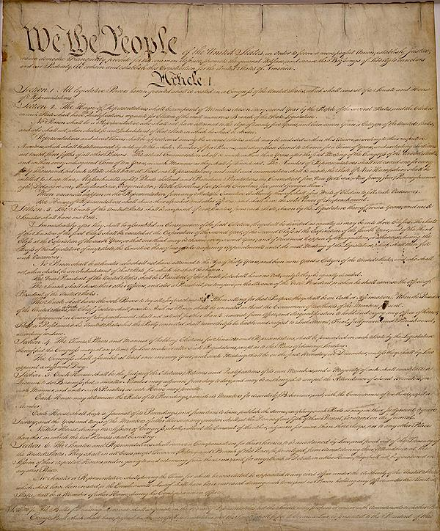
Source: The Constitution. 8 Jan. 2009 <http://www.usconstitution.net/gifs/docs/cpage1.jpg>.

The Preamble to the Constitution

We the People of the United States,

in order to form a more perfect union,

establish justice,

insure domestic tranquility,

provide for the common defense,

promote the general welfare,

and secure the blessings of liberty to ourselves and our posterity,

do ordain and establish this Constitution for the United States of America.

Analyzing a Section of the Preamble

Your assigned section of the Preamble
What does it mean?
Why is it important?
Give an example of how the federal government carries out that purpose.

What Does the Preamble Mean?

To form a more perfect union
To establish justice
To insure domestic tranquility
To provide for the common defense
To promote the general welfare
To secure the blessings of liberty to ourselves and our posterity

