s

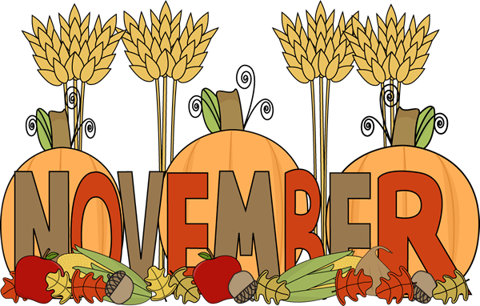

First Grade

Classroom Newsletter

5 + 6 = 11

   



**PHONICS**

● This week students will be reviewing the /sh/ /ch/ /th/and writing words with the these sounds.

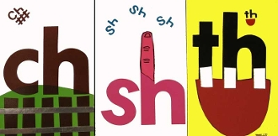

Spelling

Our spelling words this week are:

**math, with, much, fish, dish**

**Sight words –all, am**

Science

* Students will sorting states of matter (solids and liquids). Have your child walk around the house and identify solids and liquids.



**Announcements**

● If your parent-teacher conference is scheduled for this week you will be reminded with a separate note regarding your scheduled time. If your conference is scheduled for next week then you will receive a note next Monday.

● Thank you to all the parents who attended the reading workshop! Your dedication in your child’s education is greatly appreciated.

# Math

During math students will be working on the following concepts:

●Place Value: Counting base ten blocks with tens and ones.

●Identifying different math representations for addition number sentences.

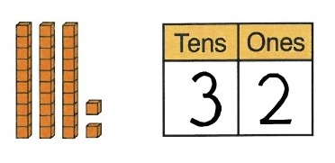

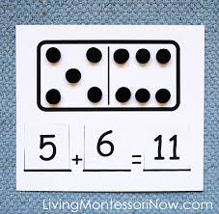

**Week of:**

**November 9**

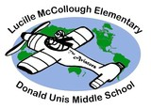



First Grade Classroom Newsletter Page 2

