**Eureka Math**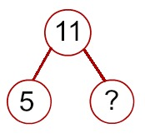

**Parent Resources**

**How can I help my child with their math?**

<https://bit.ly/35QeXMc>

Look no further, just scan the QR code or use the link above for many resources to support your child in learning math concepts.