Buckeyes Recipe

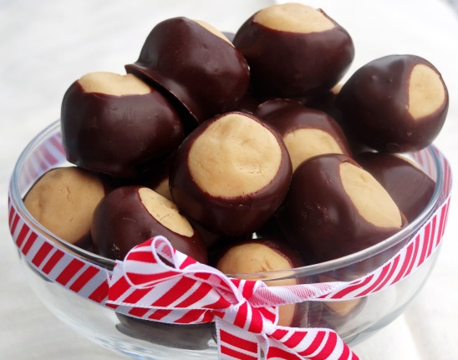

Preparation time: **15 -20 minutes**

Cook Time- **5 minutes**

Ready In- 50 minutes

Serving Size-About 3 Buckeyes for each student

Ingredients:

2 Tablespoons of Peanut Butter

2 Tablespoons of Butter

1/16teaspoon Vanilla Extract

¾ cup of powdered sugar

¼ chocolate chips used for dipping

**Directions:**

1. **In a large bowl, mix together the peanut butter, vanilla and powdered sugar. The dough will look dry. Roll into 1 inch balls and place on a waxed paper-lined cookie sheet.**
2. **Press a toothpick into the top of each ball (to be used later as the handle for dipping) and chill in freezer until firm about 30 minutes.**
3. **Melt chocolate chips in a double boiler or microwave on high for 1 minute and check consistency. Stir until smooth.**
4. **Dip frozen peanut butter balls in chocolate holding onto the toothpick. Leave a small portion of peanut butter showing at the top to make them look like Buckeyes. Put back on the cookie sheet and refrigerate until serving.**