French Toast recipe

Ingredients: 1 Large Egg

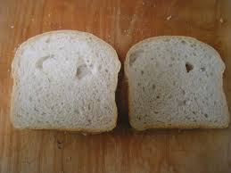Slices of Bread

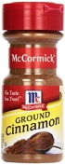

1/8 teaspoon cinnamon

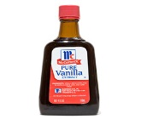

Figure Pinch of Salt

1/8 teaspoon of vanilla

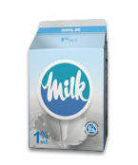

2 teaspoons of milk

DIRECTIONS

1. Whisk together egg, milk, vanilla, cinnamon, and salt in the bowl ; set aside.
2. Place bread in a shallow baking dish large enough to hold bread slices in a single layer. Pour egg mixture over bread; soak 1 minute. Turn slices over; soak until soaked through, about 1 minute more.
3. Preheat oven to 250 degrees. Place a wire rack on a baking sheet, and set aside. Heat 2 tablespoons butter and 2 tablespoons vegetable oil in a skillet over medium heat. Fry half the bread slices until golden brown, 2 to 3 minutes per side. Transfer to wire rack; place in oven while cooking remaining bread. Wipe skillet, and repeat with remaining butter, oil, and bread. Keep in oven until ready to serve. Serve warm with pure maple syrup, if desired.