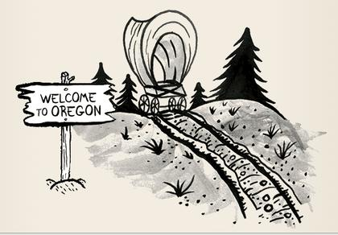Name:

Ms. Ha

WHaG Hour: 1 2 3 4 6

Date: 3-3-20

**DID YOU SURVIVE THE OREGON TRAIL?**

These are the list of supplies that 1 person would need to survive the Oregon Trail. This was the packing list:

**FOOD: #598 PERSONAL ITEMS: #76 MISC: #60**

4 (50 lb.) bags of flour =200 lbs. 1 knife (3)=3 lbs. 1 (20) water=60 lbs.

6 (25 lb.) bags of bacon=180 lbs. 1 powder horn (4)=4 lbs.

1 (20 lb.) of sugar =20 lbs. 1 (clothing for 1) (20)=20 lbs.

1 (5 gal) vinegar=25 lbs. 1 eating utensils (2)=2 lbs.

1 (5 lb.) of fruit=8 lbs. 2 pistol (4)=8 lbs.

4 (25 lbs.) of beans=100 lbs. 2 rifle (6)= 12 lbs.

1 spices=5 lbs. 1 eating utensils (2)=2 lbs.

2 (25 lbs.) of salt=60 lbs. 1 first aid kit (10)= 10 lbs.

**HOUSEHOLD: #200** 1 boot (7)= 7 lbs.

1 cooking utensils (4)=4 lbs. 1 chaps (8)= 8 lbs.

2 lanterns (3)=6 lbs. **TOOLS: #66 YOU SURVIVED IF:**

2 (5 candles 1)=2 lbs. 1 pick axe (5)=5 lbs.  **A) Awesome: 0-5 missing**

1 dishes (20)=20 lbs. 1 100’ rope (6)=6 lbs. **B) Good Chance: 6-8 miss**

5 matches (2)=10 lbs. 1 hatchet (1)= 4 lbs. **C) Maybe: 9-11 miss**

1 cooking pan (6)=6 lbs. 1 shovel (7)= 7 lbs. **D) Not likely: 12-14**

1 bed (30)=30 lbs. 1 hammer (2) = 2 lbs.  **E) Nope: 15 plus missing**

1 bedding for 1 bed=2 lbs. 1 hoe (4)= 4 lbs.

3 blankets (7)=21 lbs. 1 tools (10) = 10 lbs.

1 cooking stove (75)=75 lbs. 1 axle grease (13) = 13 lbs.

1 coffee pot (3)=3 lbs. 1 oxen yoke repair (15) = 15 lbs.

1 butter churn (10)=10 lbs. **YOU HAD TO HAVE:** OXEN / FLOUR / BEANS /

1 needle & thread (1)=1 lb. WATER/ SALT /CLOTHING / RIFLE / FIRSTAID KIT

1 pitcher/bowl (10)=10 lbs. ROPE / SHOVEL / HAMMER / TOOLS / MATCHES