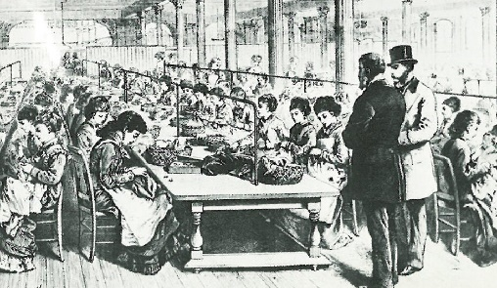Name:

Ms. Ha

WHaG Hour: 1 2 3 4 6

Date: 2-12-20

**Industrial Revolution**

**Study Guide**

Directions: write out your study guide on a separate piece of paper.

Terms / Concepts / People

1. Factory 18. Andrew Carnegie-industry he ran? Carnegie Steel Co.
2. Industrialization 19. J.D. Rockefeller-industry he ran? Founded Standard Oil
3. Urbanization 20. Cholera-how did you get?
4. Cottage Industry 21. TB-how did you get?
5. Enclosure Movement 22. Capitalism
6. Crop Rotation 23. Adam Smith
7. Laissez Faire 24. *The Wealth of Nations*
8. Strike 25. Karl Marx

9. Unions 26. Communism & “The Communist Manifesto”

10.Mass Production 27. Socialism

1. Steam Engine 28. Thomas Alva Edison (filament light bulb)
2. James Watt 29. Robert Fulton (steamboat Clermont)
3. Bessemer Process 30. Standard of Living
4. Spinning Jenny 31. Pollution
5. John Hargreaves 32. Parliament
6. Eli Whitney
7. Cotton Gin

Essential Questions

1. Why did the Industrial Revolution originate (start) in England? (foldable 2-3-20)
2. Why was England a great location for the Industrial Revolution to begin?
3. Describe the hours, number of days that the lower class / kids were expected to work.
4. Describe the dangers working in a factory or mine.
5. Why did children, as young as 5 to 6 work?
6. Describe, in detail, the problems that existed in housing for the poor.
7. Describe how the Middle Class grew.
8. Identify four positive effects of Industrialization.
9. Identify four negative effects of Industrialization.
10. Describe two new types of transportation due to industrialization.
11. List and explain the four factors of production (Land, Labor, Capital, Entrepreneur)
12. USA-city that was the steel capitol of the world.
13. What do you make gasoline from?
14. Prior to 1865, ______________ did not spread West of the Mississippi River.
15. Describe five inventions during the Industrial Revolution. (foldable 2-7-20)