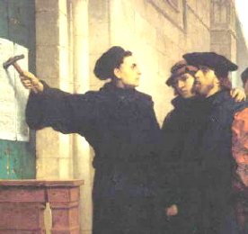Name:

Ms. Ha

WHaG Hour: 1 2 3 4 6 Study Guide

Date: 11-14-19 The Reformation

Directions: answer all the items below, in detail, on a separate sheet of paper. Use your notes, work sheets etc. to help you.

**VOCABULARY**

1. Reformation 6. Heretic 11. Archbishop 16. The Bible
2. Indulgences 7. Salvation 12. Catholic 17. Printing Press
3. Purgatory 8. Thesis 13. Vatican
4. Excommunicate 9. Annulment 14. Protestant
5. Reformer 10. Divorce 15. Recant

**PEOPLE**

1. Johanne Gutenberg 5. Pope 9. Henry VIII 13. Pope Leo X
2. John Wycliffe 6. Queen Elizabeth I 10. Jane Seymour 14. John Tetzel
3. Jesus Christ 7. Catherine of Aragon 11. Edward (kid) 15. Anne Boleyn
4. Martin Luther 8. Mary 12. Pope Clement VII 16. John Huss

**QUESTIONS**

1. Why was the Middle Ages called the “Time of Faith?”
2. Why did John Wycliffe and John Huss criticize the Church? Explain what each did and what happened to them, if anything for challenging the Catholic Church.
3. What had always troubled/worried Martin Luther about death?
4. Explain why the Catholic Church was offering indulgences. Why did Martin Luther oppose this?
5. Explain why Henry VIII wanted to break away from the Catholic Church.
6. What new Church did Henry VIII create?
7. Explain why Henry VIII had the Queen, Anne Boleyn beheaded?
8. Explain how Henry VIII was able to arrange a divorce of his first wife, Catherine of Aragon.