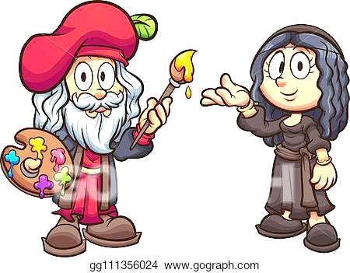Name:

Ms. Ha

WHaG Hour: 1 2 3 4 6 / 110 Study Guide

Date: 10-30-19 The Renaissance

Directions: write out the information below on a separate piece of paper.

VOCABULARY (32)

1. Renaissance 5. Realism 9. Printing Press 13. Plaster
2. Optimism 6. Renowned 10. Portrait 14. Vatican
3. Humanism 7. Meticulous 11. Sculptor 15. Fresco
4. Bubonic Plague 8. Middle Ages 12. Patron 16. Buboes

PEOPLE (18)

1. Lorenzo de Medici 4. Verrochio 7. King of France, Francis I
2. Johann Gutenberg 5. Pope 8. Christopher Columbus
3. Plato 6. Michelangelo 9. Beatrice d’Este

QUESTIONS (60)

1. Compare and contrast the attitude towards life from the Middle Age and Renaissance point of view. (4)
2. When did the Renaissance begin and end? (4)
3. Explain why the Renaissance begin in Italy of all places? (2)
4. Why do historians view the Renaissance as the beginning of modern history? (2)
5. Identify the Latin word that is another term for “Renaissance.” (2)
6. Explain what the Renaissance actually was. (4)
7. Explain what humanism emphasized and how did it help spread the Renaissance? (4)
8. Explain how, during the 1300s, Western Europe experienced a difficult time. (4)
9. From what years did the Bubonic Plague exist in Europe? __ to ___ (4)
10. Does the Bubonic Plague exist today? If so, can it be treated? (4)
11. How many people were killed during the Bubonic Plague or Black Death? (2)
12. In England, what fraction of the population died from the Bubonic Plague? (2)
13. Explain, in detail, how the Black Plague started and how humans contracted (caught) it. (6)
14. Explain how the impact of the Black Plague changed people’s perspectives on life. (4)
15. Identify the characteristics a “Renaissance Man” was supposed to have. (6)
16. Identify the characteristics a “Renaissance Woman” was supposed to have. (6)

ARTWORK: identify the artwork to the creator. Explain what the artwork depicts (shows)

Leonardo da Vinci: The Mona Lisa & The Last Supper Michelangelo: Pieta & The Sistine Chapel