Name:

Ms. Ha

WHaG Hour: 1 2 3 4 6 /40 Bell Work

Date: 10-30-19 Renaissance Review

Directions: use your notes, memory and book to help you answer the questions below. LABEL THE ITEMS IN THE CORRECT LOCATION. **Maps: pp: 469 and A 23**

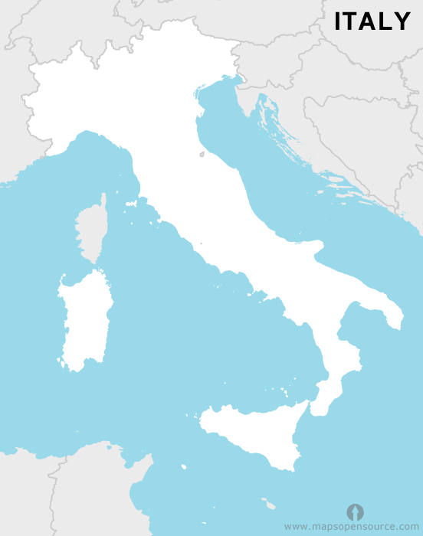

|  |
| --- |
| WORD BANK |
| Adriatic Sea (2)  Corsica (2)  Sicily (2)  Star Rome and label it (4)  Alps: draw upside down V’s / label (4)  Mediterranean Sea (4)  Tyrrhenian Sea (2)  Apennine Mts. Upside down V’s/label (4)  Sardinia (2) |

1. Another name for Renaissance(2)
2. Renaissance began in _________ &

was done by the __________. (4)

1. The Bubonic Plague killed _________ million people and came to Italy by ____________ (4).
2. The Bubonic Plague still exists today. TRUE FALSE (circle) (2)
3. The Middle Ages was full of optimism and happiness for people. TRUE FALSE (circle) (2)