Name:

Ms. Ha

WHaG Hours: 1 2 3 4 6

Date: 10-30-19 Differentiated Notes

Directions: follow along with the notes and fill in the blanks.

Content Objectives:

1. SWBAT compare and contrast the great Renaissance artists Leonardo da Vinci and Michelangelo.
2. SWBAT identify and explain two major works of art from each of the Renaissance artists.

Language Objectives:

1. “I CAN” compare and contrast the great Renaissance artists Leonardo da Vinci and Michelangelo by taking notes, looking at pictures and using class discussion time.
2. “I CAN” distinguish the different works of art through pictures, class discussions and a foldable.

RENAISSANCE MEN

The Renaissance Men: Leonardo da Vinci and Michelangelo

1. Leonardo da Vinci
2. Background
3. Poor _________________________
4. 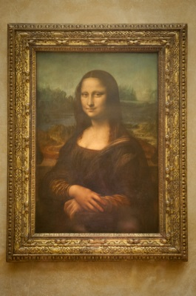Father put him into ____________________ at a young age for _______________
5. Two best pieces of work
6. The __________________ _______________
7. Famous _____________________________
8. __________________: a drawing of a person
9. __________________: person who supports an artist with money
10. Leonardo: second piece
11. “The ________________ ___________________”
12. Jesus of Nazareth ___________________ with disciples (followers) the night before he was ___________________________
13. FRESCO: a painting done in wet ________________ on a _______________
14. The Last Supper: painted in wet plaster
15. 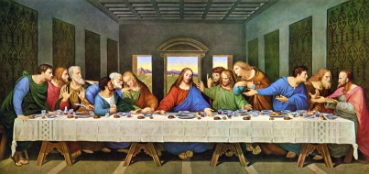PLASTER: a mixture of __________________, water, and _____________ that gives a ______________________ finish to a wall.
16. Famous patrons: Beatrice de Este and King of France, __________________ I.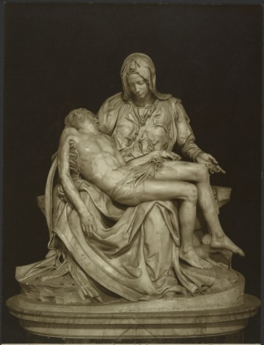
17. Michelangelo
18. Born near __________________ in 1475
19. Always a ___________________ FIRST!
20. Lorenzo de ______________________ helped him
21. First masterpiece: ________________
22. Means ________________
23. Mary holding her dead son ___________________
24. Sistine Chapel
25. He was asked to paint ceiling of __________________ in Rome.
26. Sistine Chapel: small ____________________
27. __________________: Pope lives
28. Bible stories: creation to flood

QUICK FACTS:

1. The Sistine Chapel ceiling took 22 years to paint. T F Answer:
2. There are over 300 figures on the ceiling. T F Answer:
3. Some figures are over 10 feet tall. T F Answer:
4. Michelangelo painted by candle light. T F Answer: