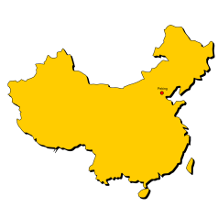Name:

Ms. Ha

WHaG Hours: 1 2 3 4 6 Geography of China

Date: 10-2-19 Anticipation Guide

Directions: Circle the items as either true or false. We will see if you are right/wrong during the lesson!

Make any corrections below the question.

1. China is considered a large country. TRUE FALSE
2. China was invaded many times. TRUE FALSE
3. The Change River had the earliest Chinese civilization. TRUE FALSE
4. The Himalayas divide Egypt from China. TRUE FALSE
5. The Great Wall is found in northern China. TRUE FALSE
6. China is located off the Pacific Ocean. TRUE FALSE
7. The Silk Road began in China. TRUE FALSE
8. The Gobi Desert is East of China. TRUE FALSE
9. The Huang River is near the Yellow Sea. TRUE FALSE