Name:

Ms. Ha

WHaG Hour: 1 2 3 4 6 UNIT STUDY GUIDE

Date: 9-16-19

Directions: you must write out all the items below and practice your map location that is included on the back. Go OVER NOTES A LOT!

|  |  |  |  |
| --- | --- | --- | --- |
| **Mesopotamia** | **Egypt** | **Greece** | **Romans** |
| Mesopotamia  Cuneiform  Stylus  Scribe  Dam  Irrigation System  Ziggurat  Hanging Gardens of Babylon  Clay tablet | Pyramid  Mummy  Hieroglyphics  Cataracts  Polytheism  Cataracts | Trojan Horse  City-State  Homer  Olympics  Sophists  Merchant  Socratic Method  Minoan Fresco | Aqueducts Dictator  Roads 12 Tables  Arches Tribune  Patricians  Plebeians  Etruscans  Senate  Consul |
| Hammurabi  King Nebuchadnezzar | King Tut  Hatshepsut  Howard Carter  Pharaoh | Homer Philip II  Socrates Minoans  Plato Macedonians  Aristotle Mycenaean  Alexander the Great  “Iliad and Odyssey” | First Triumvirate Cleopatra   1. Julius Caesar Brutus 2. Crassus Cassius 3. Pompey   Second Triumvirate   1. Antony 2. Octavian 3. Lepidus Form |

Questions:

1. Explain how the Mesopotamians were able to tame the Euphrates and Tigris Rivers to make it an ideal place to grow food.
2. Explain how the Egyptians benefitted from the Nile River flowing north into the Mediterranean Sea.
3. Explain how Alexander the Great created such a large empire.
4. Explain how Julius Caesar rose up to be a dictator but died at the hands of his friends.

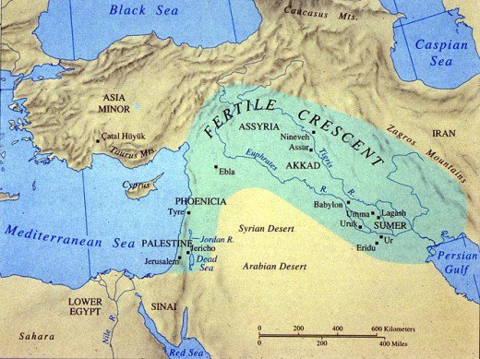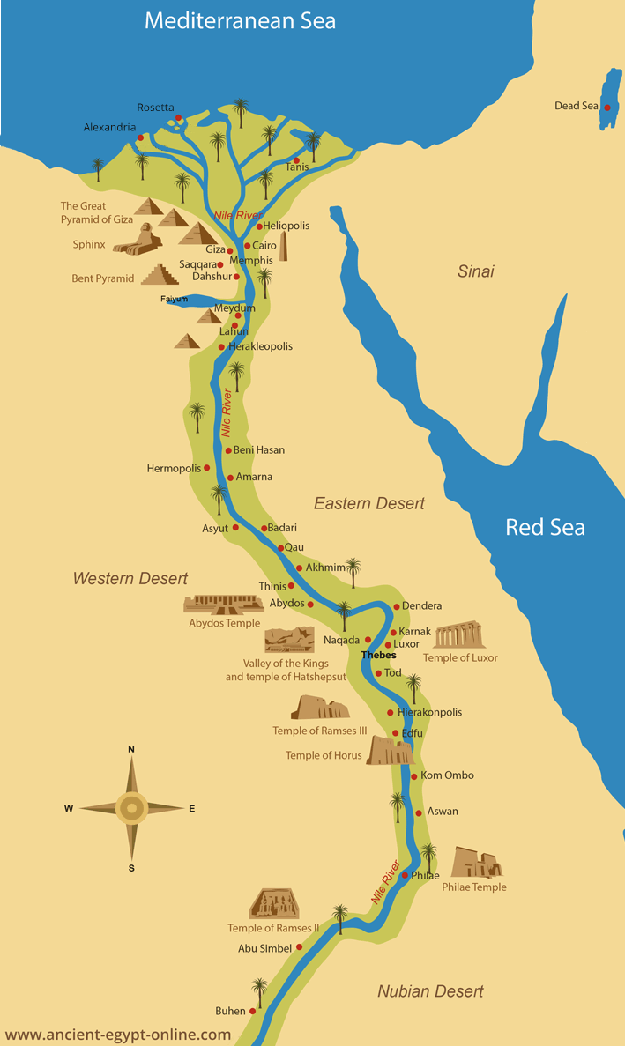MESOPOTAMIA EGYPT

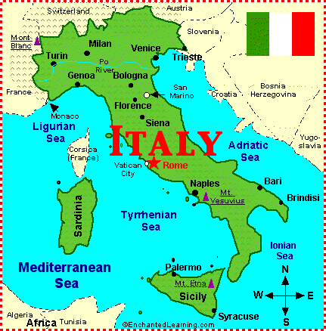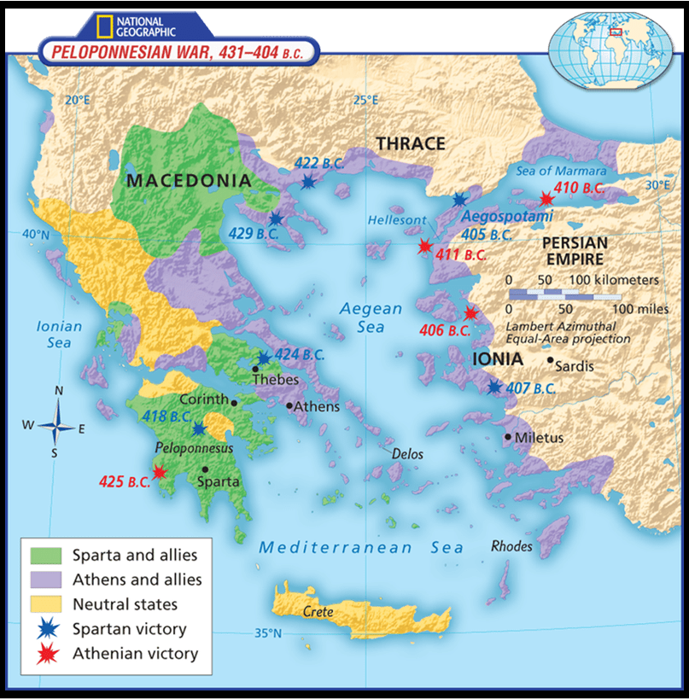

GREECE ITALY