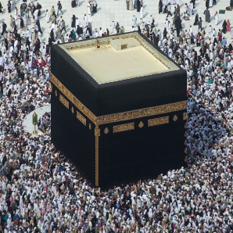Name:

Ms. Ha

WHaG Hour: 1 2 3 4 6 Islam

Date: 9-25-19 Study Guide

Directions: answer the questions on a separate piece of paper. This will be checked tomorrow in class.

VOCAB

1. Mecca 7. Nomad 13. Kiswa 19. Ulama
2. Medina 8. Quran 14. Yathrib 20. Bazaar
3. Hajj 9. Arabic 15. Pilgrimage 21. Mosque
4. Prophet 10. Arabian Peninsula 16. Mosaic
5. Kaaba 11. Monotheism 17. Ramadan
6. Idol 12. Polytheism 18. Sanctuary

PEOPLE

1. Allah
2. Muhammad
3. Angel Gabriel
4. Bedouins
5. Khadijah
6. Jesus

QUESTIONS

1. Identify and explain the Five Pillars of Islam.
2. Explain the rights that women have under Islam.
3. Describe the early life of Muhammad.
4. Who is Ibrahim and how does Muhammad relate to him?
5. What items were traded along the trading routes through Mecca?
6. How has the Kaaba been modified over time?
7. When was Muhammad born? Death?
8. What is the Black Stone and where did it come from?
9. What damages have the Kaaba endured but has been rebuilt?
10. Compare and contrast how Muslims make the Hajj in the 1700s to today.
11. What is the Muslim Way of Life? (Identify some beliefs)