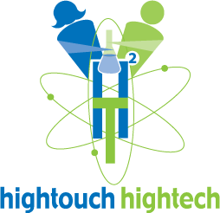 | High Touch High Tech®  Science Experiences That Come To YouTM  www.ScienceMadeFunDET.net

Greetings!
High Touch High Tech is delighted to be visiting your child’s classroom. High Touch High Tech serves many schools providing our unique blend of hands-on science experiences presented in a fun and participatory manner, as an in-school “field trip.”

High Touch High Tech has been presenting totally hands-on and participatory science experiences to students across the nation for over 15 years. The programs are curriculum based and aligned to meet and exceed the Grade Level Content Expectations and directly address MEAP topics. At the same time, these programs spark a child’s interest in science and fuel their imagination and curiosity for science in a totally participatory and fun manner.

Dear Parents,

We are looking forward to taking part in this 90 minute “in-house” field trip. This is another great opportunity for your students to be actively involved in our science curriculum. Every student participates in each experiment and even brings home some souvenirs. Please send in Cash with your student.

Program Subject: Up, Up & Away
Program Date and Time: March 16, 2012
Cost per student: $ 7.00
Money Due By: March 15, 2012
Thanks for your continued support.

