Midterm Study Guide
Review of Biomes: Write the name of the biome that is being described.
- Hot, dry and very little annual rainfall: ____________________
- Tropical, humid, 400 inches of rain per year: _____________________
- Grasslands, few scattered trees, usually warm: ___________________
Review of Latitude and Longitude:
- Which line is the vertical line on the globe? _____________________
- Which line is the horizontal line on the globe? ___________________
- How do we measure lines of latitude? _________________________
- How do we measure lines of longitude? _______________________

Review of the hemispheres: Label the hemispheres on the map below
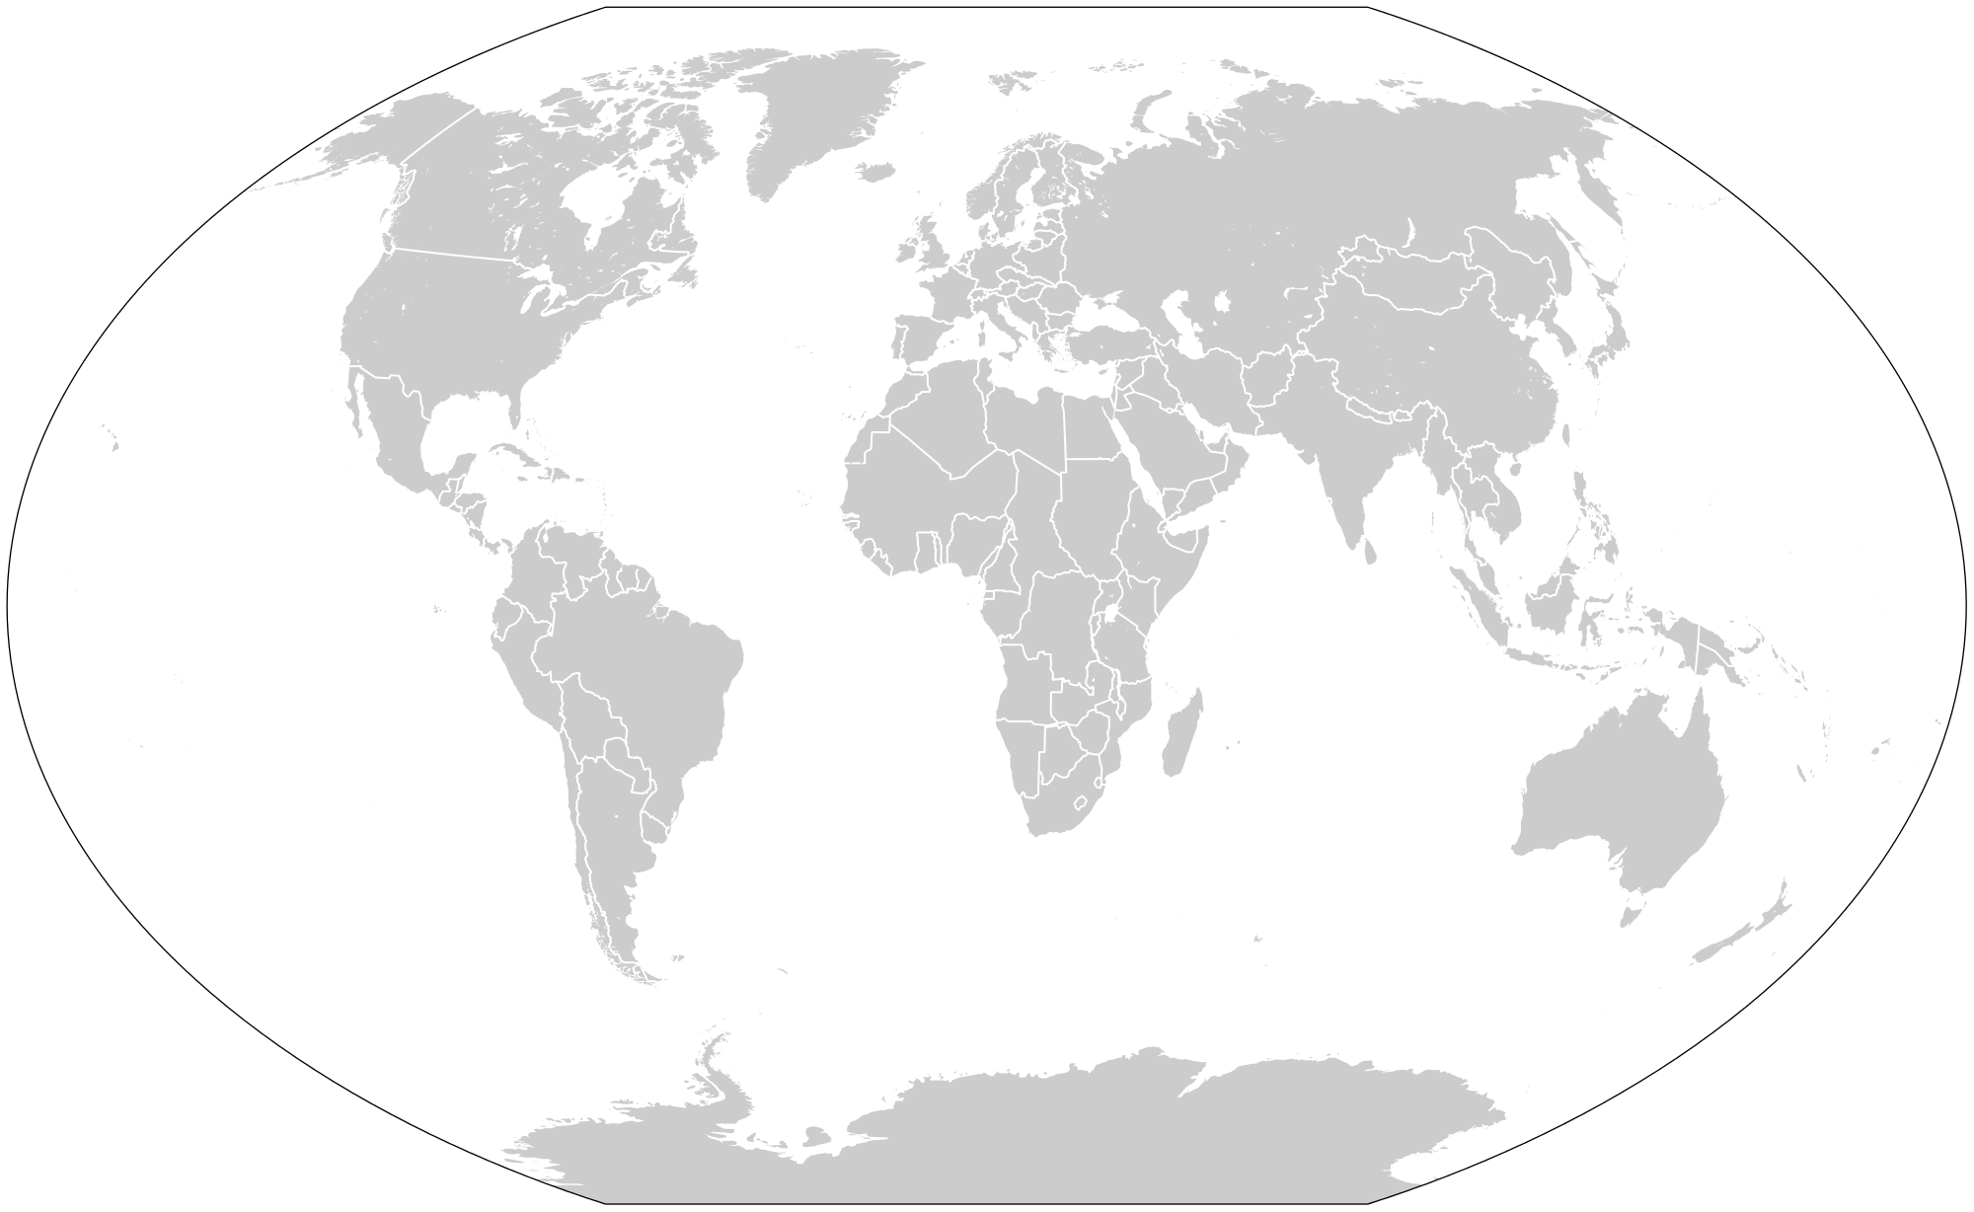
Label the 7 Continents and 5 Oceans on the map below
South America North America Australia Europe
Arctic Ocean Atlantic Ocean Asia Indian Ocean
Antarctica Pacific Ocean Southern Ocean Africa

Review of the theme of Movement: Define the terms below.
- Migration: ________________________________________________________
- Immigration: ______________________________________________________
- Emmigration: _____________________________________________________
- Import: ____________________________________________________________
- Export: ____________________________________________________________

Review of Human/Environment Interaction: Define the terms below and give examples of each.
- Modify: ____________________________Example: ________________________
- Adapt: ____________________________ Example: __________________________
- Depend: ___________________________Example: __________________________

Review of Regions: Label the 5 regions of the United States on the map below.
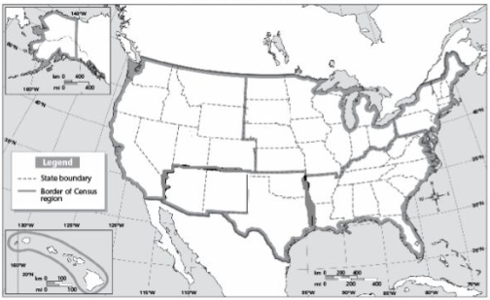
Northeast Region West Region Southwest Region
Southeast Region Midwest Region

