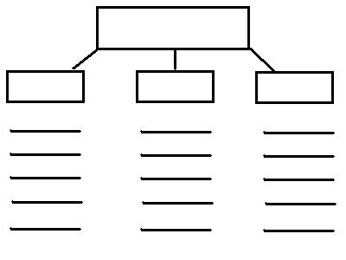

31

31

31

21

21

21

11

11

11

Closing statement

How did it make a difference in the lives of people or yourself?

Paragraph #3

Paragraph #4

Paragraph #2

Paragraph #1

Who? What? And Where?

Other inventions related and fun facts

Name the invention:

Purpose:

Why did you choose this topic?