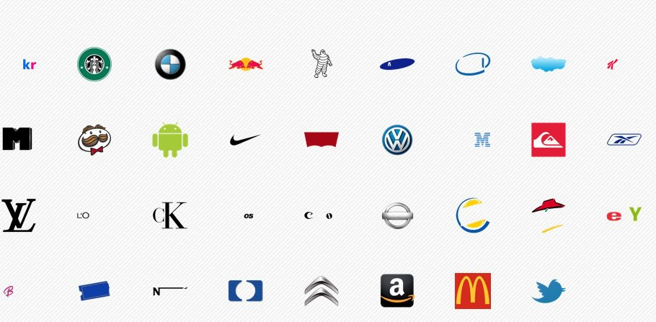

How many of these logos can you name?

Why do some look very familiar and others do not?

How does the Logo display what the company sells or does it?