Hand tool, power tool and machines

**Directions: below are pictures of various hand tools, power tools and machines used in the technology lab. You may have also used these at home. Besides each picture write down the name of the tool and describe how it is used. You can discuss these with a partner at your table.**

1. **Power tools: use a plug or battery and are either hand held or tabletop.**

Tool name: ___Miter Saw___________

Sometimes also called: _Chop saw____

How is it used: cuts boards up to 6” in width, and at any angle, by bringing the blade downward and then carefully lifting up, not letting go of the handle suddenly. Hold the board down with your hand but make sure to not be in the path of the blade.

Safety equipment required to use this machine: safety glasses and make sure that the blade guard (the plastic piece covering the blade) is operating properly. Do not wear gloves!

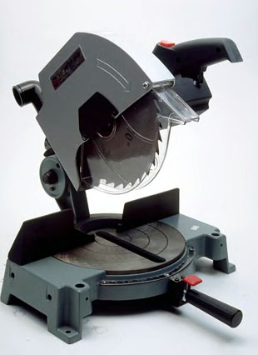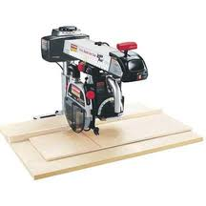

Tool name: ____Radial Arm Saw_

How is it used: cuts wider boards up to 1’ in width by slowly pulling the handle forward and then slowly pushing it back to the starting position. You will need to make sure the board is stable by holding it down and keeping your hand from the path of the blade.

Safety equipment required to use this machine: safety glasses and make sure that the blade guard (the plastic piece covering the blade) is operating properly. Do not wear gloves!

Tool name: ___Claw hammer ______

How is it used: Used to drive in nails with the flat end and remove them with the claw end. This tool is used only with nails and no other tool.

Safety equipment required to use this machine: Safety glasses because this is a striking tool.

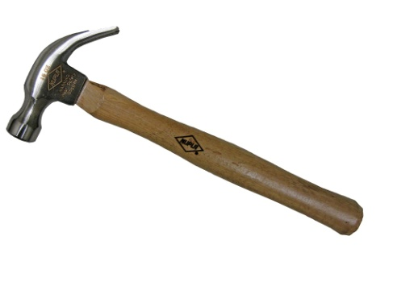

Tool name: __Mallet__________

How is it used: This tool is typically used with a chisel or gouge to remove wood such as a sculptor creating a statue. We would use the mallet with a chisel to separate two boards that may have not glued correctly and must be redone.

Safety equipment required to use this machine: Safety glasses because this is a striking tool

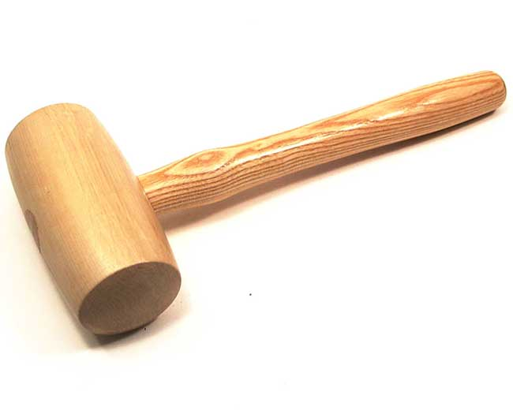

Tool name: ___flathead screwdriver_________

How is it used: Drives screws in which have a minus sign on the screw head. Also used to remove these same screws.

Safety equipment required to use this machine: Safety glasses preferred but not required unless you are using a power drill with a flathead attachment.

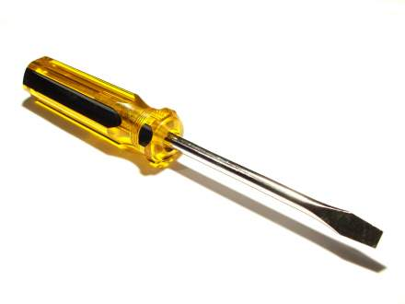

Tool name: phillips screwdriver

How is it used: : Drives screws in which have a plus sign on the screw head. Also used to remove these same screws.

Safety equipment required to use this machine: Safety glasses preferred but not required unless you are using a power drill with a phillips attachment.

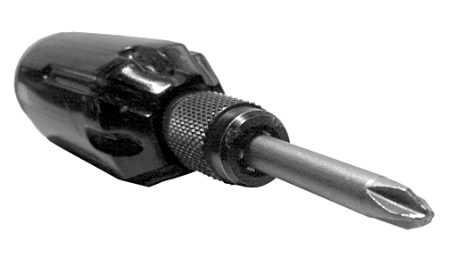

Tool name: __level________

How is it used: Checks for perfect vertical or horizontal leveling as it relates to the ground. A bubble within two black lines will indicate level.

Safety equipment required to use this machine: Safety glasses preferred but not required.

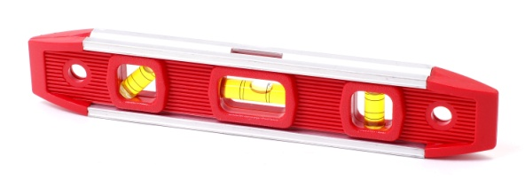

Tool name: __Chisel___________

How is it used: Only used with a mallet to separate two boards or to remove material when creating a statue or similar project.

Safety equipment required to use this machine: Safety glasses because this is used with a striking tool. You must also direct the cutting away from you so that the in case the blade slips you are not harmed.

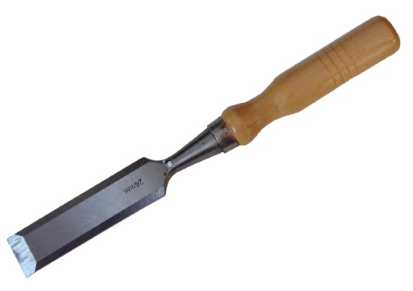

Tool name: ___file_______________

How is it used: It smooth’s the material after cutting but before sanding. It Files can be found in various sizes, shapes and textures based on what is being filed. Round files are used with holes with curved cuts and flat files used with flats cuts.

Safety equipment required to use this machine: Safety glasses due to the possibility of sawdust coming in contact with your eyes.

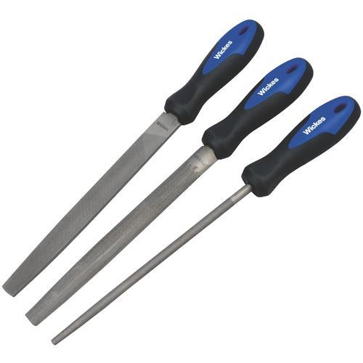

Tool name: ___clamp_____________

How is it used: Comes in various types such as the wood clamp, “c” clamp and adjustable clamp and all are used to hold wood either to a workbench, a drill press table or hold wood together of gluing, sanding or drilling.

Safety equipment required to use this machine: safety glasses are required if you plan to cut or sand the material the clamp is attached to. If you are just using clamps to hold the material for gluing then glasses are not needed.

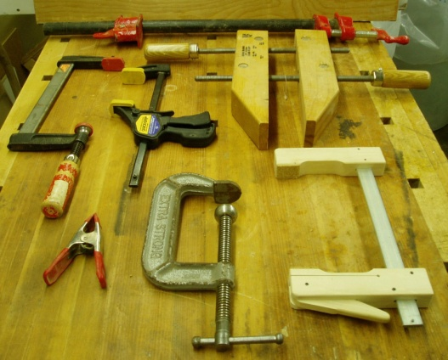

Tool name: _hand saw____

How is it used: Cuts the board using a downward stroke. You will need a clamp to secure one end of the board to a workbench before cutting and make sure that no one is in the area in which the cutting will occur.

Safety equipment required to use this machine: safety glasses are required due to possible sawdust

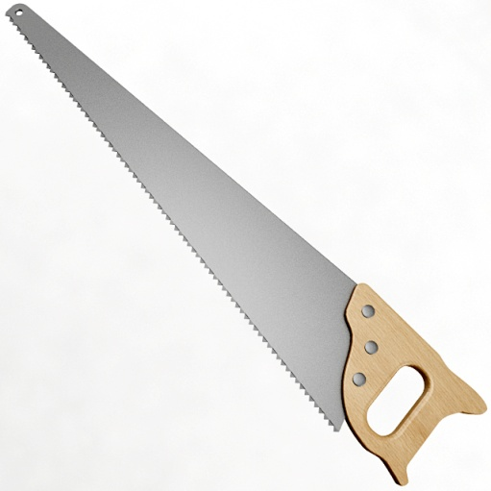

Tool name: Drill press

How is it used: Cuts holes in wood. A clamp and chuck key are required when using this machine.

Safety equipment required to use this machine: safety glasses

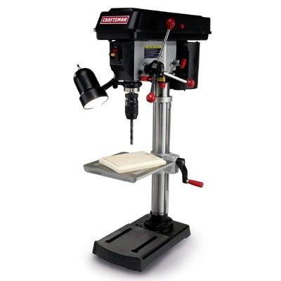

Tool name: Drill bit

How is it used: cuts holes in wood, or other materials. Comes in many different shapes and sizes. Use dwith a drill press or cordless drill.

Safety equipment required to use this machine: safety glasses

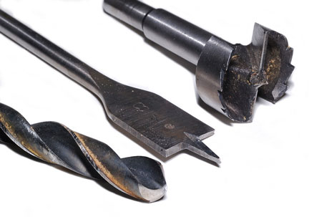

Tool name:

How is it used:

Safety equipment required to use this machine:

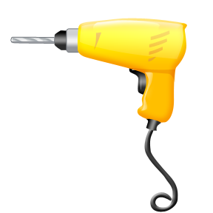

Tool name: __chuck key___

How is it used: Used with the drill press to tighten or loosen the chuck so that a bit may be added or removed

Safety equipment required to use this machine: You should already have glasses on because you are at a machine.

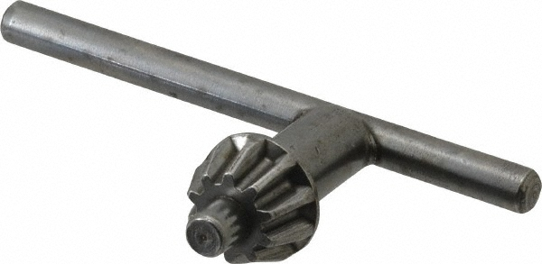

Tool name: miter box and back saw

How is it used: Used to cut narrow pieces of wood at either 90 or 45 degree angles. Use with a clamp.

Safety equipment required to use this machine: You should already have glasses on because you are using a saw.

