**Student Record Keeping**

Fitness Pretest Scores (Fall)

|  |  |  |  |  |
| --- | --- | --- | --- | --- |
| **Test** | **Your Score** | **National Standard** | **Presidential Standard** | Write a **P** if you met the standard for Presidential. Write an **N** if you met the standard for National. |
| Curl-Ups (sit ups) |  |  |  |  |
| Sit & Reach (cm) |  |  |  |  |
| Pull-Ups |  |  |  |  |
| Flexed Arm Hang (seconds) |  |  |  |  |
| Shuttle Run (seconds) |  |  |  |  |
| Mile Run |  |  |  |  |

1. Based on your current level of fitness, do you meet the standards of the National Physical

Fitness Award (50th%)?__________.

2. Have you met the standards for the Presidential Physical Fitness Award (85th

percentile)?_________.

3. In 3 to 4 sentences, please describe your current level of overall fitness. What factors have contributed to your

fitness level? What could you do to improve?

Fitness Post Test Scores (Spring)

|  |  |  |  |  |
| --- | --- | --- | --- | --- |
| **Test** | **Your Score** | **National Standard** | **Presidential Standard** | Write a **P** if you met the standard for Presidential. Write an **N** if you met the standard for National. |
| Curl-Ups (sit ups) |  |  |  |  |
| Sit & Reach (cm) |  |  |  |  |
| Pull-Ups |  |  |  |  |
| Flexed Arm Hang (seconds) |  |  |  |  |
| Shuttle Run (seconds) |  |  |  |  |
| Mile Run |  |  |  |  |

Presidential Award Standards (85th%)

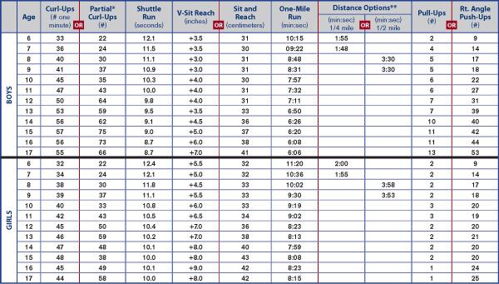

National Award Standards (50th%)

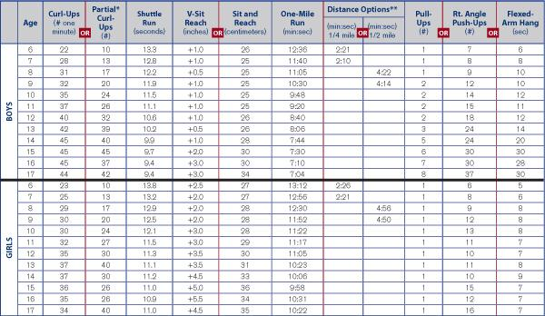

END OF THE YEAR REFLECTION. Please write a detailed reflection about how your year in physical education went. In your reflection be sure to answer the following questions. (Please write your reflections using complete sentences on a separate piece of paper.)

Did you reach your goals? Explain with evidence.

Did keeping track of your summative grades in physical education help you learn?

What was one thing you really liked about physical education class and one thing you didn’t like so much?

|  |  |  |  |  |
| --- | --- | --- | --- | --- |
| Summative Assignment. (Tests, quizzes, projects)Card marking grades. (Highlighted) | Date | Goal Grade | Grade Earned | Two ways you can improve or keep your current grade. |
| Fitness Pretest | 9/11/2017 |  |  |  |
| Soccer Pretest | 10/2/2017 |  |  |  |
|  |  |  |  |  |
|  |  |  |  |  |
|  |  |  |  |  |
|  |  |  |  |  |
|  |  |  |  |  |
|  |  |  |  |  |
|  |  |  |  |  |
|  |  |  |  |  |
|  |  |  |  |  |
|  |  |  |  |  |
|  |  |  |  |  |
| Summative Assignment. (Tests, quizzes, projects)Card marking grades. (Highlighted) | Date | Goal Grade | Grade Earned | Two ways you can improve or keep your current grade. |
|  |  |  |  |  |
|  |  |  |  |  |
|  |  |  |  |  |
|  |  |  |  |  |
|  |  |  |  |  |
|  |  |  |  |  |
|  |  |  |  |  |
|  |  |  |  |  |
|  |  |  |  |  |
|  |  |  |  |  |
|  |  |  |  |  |
|  |  |  |  |  |
|  |  |  |  |  |
| Summative Assignment. (Tests, quizzes, projects)Card marking grades. (Highlighted) | Date | Goal grade | Grade Earned | Two ways you can improve or keep your current grade. |
|  |  |  |  |  |
|  |  |  |  |  |
|  |  |  |  |  |
|  |  |  |  |  |
|  |  |  |  |  |
|  |  |  |  |  |
|  |  |  |  |  |
|  |  |  |  |  |
|  |  |  |  |  |
|  |  |  |  |  |
|  |  |  |  |  |
|  |  |  |  |  |
|  |  |  |  |  |