**2nd Grade – Unit 9 Pre-Test**

Circle the best tool to measure each object. 2.MD.1

1) your wrist Ruler Yardstick Measuring Tape

2) a book Ruler Yardstick Measuring Tape

3) a driveway Ruler Yardstick Measuring Tape

4) Measure the stapler to the nearest inch. 2.MD.1

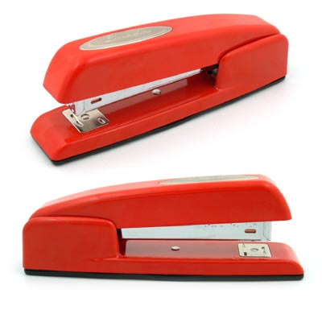

The stapler is __________ inches long.

5) What measurement tool would you use to measure the length of a paper clip? Explain your thinking. 2.MD.1

_____________________________________________________________

_____________________________________________________________

_____________________________________________________________

What is the length of the paintbrush? 2.MD.2

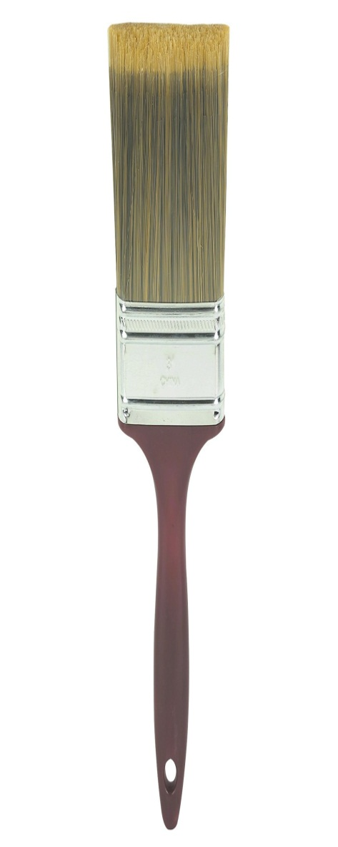

6) 5 inches Yes No

7) 15 centimeters Yes No

8) 6 inches Yes No

Estimate then measure the marker to the nearest inch and centimeter. 2.MD.2/2.MD.3

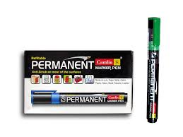

9)

10)

|  |  |
| --- | --- |
| My  Estimate | Actual  Measurement |
| about _____ inches | about ____ inches |
| about _____ cm | about _____ cm |
|  |  |

. ong.

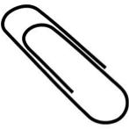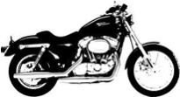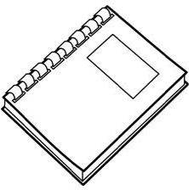

Motorcycle

Notebook

Paperclip

Circle the object that is about a foot long. Put an X on the object that is about an inch long. 2.MD.3

11)

12) Is the length of a baseball bat about 3 inches, 3 feet, or 3 yards? Explain your thinking. 2.MD.3

___________________________________________________________

___________________________________________________________

___________________________________________________________

A notebook is 12 inches long. A box is 18 inches long. A bulletin board is 36 inches long. Which of the following statement(s) are true? 2.MD.4

13) The box is 7 inches longer than the notebook. Yes No

14) The bulletin board is 2 feet longer than the notebook. Yes No

15) The notebook is 6 inches shorter than the box. Yes No

16) A bookshelf is 36 inches long. A tissue box is 9 inches long.

What is the difference in length between the bookshelf and tissue box? 2.MD.4

Show your work.

The difference between the bookshelf and tissue box is ___________ inches.

17) Explain how you could find the difference in height between your chair and your teacher’s chair. 2.MD.4

**_____________________________________________________________**

_____________________________________________________________

_____________________________________________________________

Which shape(s) have an area of 18 square units? 2.G.2



18) Yes No



19) Yes No



20) Yes No

21)Using the grid, construct a rectangle

with an area of 12 squared units.

2.G.2

22) Is there a way you can construct a rectangle with an area of 8 squared units? Explain your reasoning. 2.G.2

__________________________________________________________

__________________________________________________________