Chapter 13 MAIN IDEAS
Use your notes and the information in the chapter to answer the following questions.
Changing Ways of Life (pages 434-439)
1. Why was heavy funding needed to enforce the Volstead Act (Prohibition)?

2. Explain the circumstances and outcome of the trial of the biology teacher John Scopes.

The Twenties Woman (pages 440-443)
3. In what ways did flappers rebel against the earlier styles and attitudes of the Victorian age?

4. What key social, economic, and technological changes of the 1920s affected women’s marriages and family life?

Education and Popular Culture (pages 446-451)
5. How did high schools change in the 1920s?

6. Cite examples of the flaws of American society that some famous 1920s authors attacked in their writing.

The Harlem Renaissance (pages 452-457)
7. What do the Great Migration and the growth of the NAACP and UNIA reveal about the African-American experience in this period?

8. What were some of the important themes treated by African-American writers in the Harlem Renaissance?

Use the visual below and your knowledge of United States history to answer question 1.
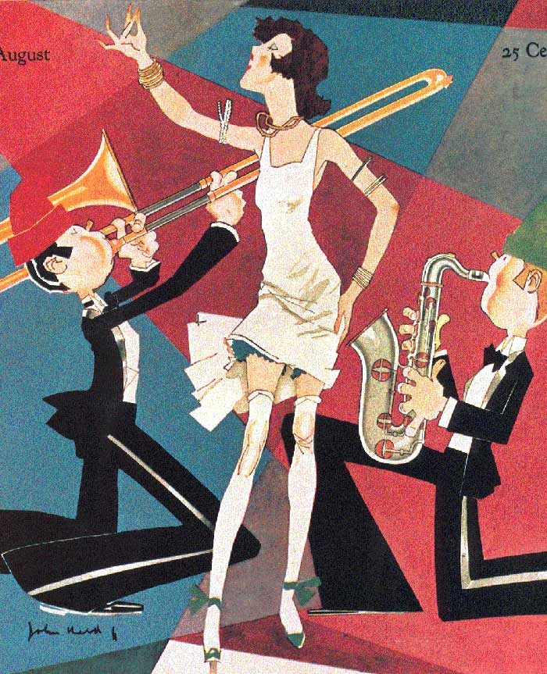
1. The woman shown on this magazine cover represents a lifestyle championed by which of the following 1920s figures?
A. Fundamentalist B. Flapper C. Suffragist D. Prohibitionist
-Explain why you chose that answer.

2. The great flowering of African-American artistic activity in the 1920s is known as?
A. the Jazz Age B. the speakeasy C. the Harlem Renaissance D. American fundamentalism
-Provide examples of people & works from this period.

Use the quotation and your knowledge of U.S. history to answer question 3.
“ No more fear, no more cringing, no more sycophantic begging and pleading; but the Negro must strike straight from the shoulder for manhood rights and for full liberty. Africa calls now more than ever.”
3. The quotation supports the “Back to Africa” movement. One important leader of this movement in the 1920s was ?
A. Marcus Garvey B. James Weldon Johnson C. Zora Neale Hurston D. Paul Robeson

-What movement did this person lead & what was the purpose of this movement?

