THE WIND & THE LION MOVIE WORKSHEET
Long before there were suicide bombers, Osama bin Laden or chants of "Death to the Great Satan," a Trenton man named Ion Perdicaris became the 20th century's first American victim of Middle Eastern terrorism.
It all happened in 1904, when the 64-year-old Perdicaris and his stepson found themselves taken hostage from their villa in Tangier, Morocco by a scruffy band of rifle-toting Berber tribesmen on horseback. The bandits' chieftain was flamboyant, black-bearded Mulai Ahmed er Raisuli, and he wanted to extort a heavy ransom from the Sultan of Morocco -- not to mention embarrass the sovereign by showing his powerlessness to protect foreign citizens.
This was more than a simple kidnapping in a distant land. For President Theodore Roosevelt, it was an opportunity to start waving his "big stick," sending battleships steaming toward the African coast to ensure Perdicaris' safe release. It also gave Roosevelt the chance to issue one of his most blood-curdling proclamations, a statement that helped ensure his re-election while sending Americans wild with joy:

"Perdicaris alive or Raisuli dead!"
Still, for all the bluster contained in that ringing phrase, Roosevelt concealed a secret that Perdicaris wasn't even an American citizen.

Pre Movie Questions:
- What African proverb (saying) did TR use to describe his foreign diplomacy?

-What did the proverb mean?

- Look at the map on p. 35, in what year & country was the Big Stick Diplomacy used?
-Describe how the policy was used?

- What was the demand TR made regarding the Perdicaris kidnapping?

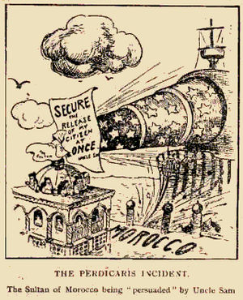
- How does the cartoon explain TR’s foreign policy?

Movie 6 Squares
Movie Titile:

DIRECTIONS: As you watch the movie, complete the following chart. Be sure to include as much information as possible. Use the back of the sheet if you need more space.

Main Characters/Importance | Where? & When? | Essential Questions
1.

2.

3.
Major Events | Comments/Thoughts | Post Movie Questions:
 | 1.  2.  3. | - What was the purpose of the big stick diplomacy?  - What was a long-lasting issue with the big stick diplomacy?  - How does big stick diplomacy affect feelings toward the U.S. today?

