Name ________________________

Martin Luther King, Jr. & the Civil Rights Movement

I. Martin Luther King & the Civil Rights Movement
A. In 1954, the Civil Rights movement began with the ____________________________________________ decision, but the rest of American society remained ____________________________:
1. The NAACP showed that the _________ Amendment could be used to challenge segregation
2. Civil rights leaders continued the fight for _______________________ until segregation came to an end in 1965
B. The Montgomery Bus Boycott
1. In 1955, __________________________ arrest for disobeying an Alabama law requiring segregation on city buses sparked the _________________________________________ Boycott
a. Minister Martin Luther King, Jr. organized a 381-day ____________ of the bus system to protest segregation
b. The boycott led to the ____________________________ of city buses & to the rise of __________________ as the leader of black civil rights
2. The success of the Montgomery Bus Boycott led MLK to form the _____________________________________ _______________________Conference (SCLC) in 1957:
a. The SCLC was formed to use activism & ________________________ protest to bring an end to segregation
b. The SCLC soon overtook the ______________________ as the leading civil rights group in America
C. Activism Through Non-Violent Protest
1. ___________________________________________________ non-violent approach inspired other groups to act
2. The Sit-In Movement & the Student Nonviolent Coordinating Committee (SNCC)
a. In 1960, students from NC A&T led a _______________ at a segregated lunch counter in Greensboro, NC
b. The “sit-in” movement led to the _________________________________ Coordinating Committee (SNCC)
3. The Freedom Rides, 1961
a. In 1961 “_________________________________________” rode ________________ throughout the South to test whether integration orders were being enforced
b. Freedom riders faced arrest & ____________________ but exposed the lack of enforcement of desegregation laws in the Deep South
D. In 1963, MLK organized a march to integrate Birmingham, Alabama
1. _____________________________ was considered the “most segregated city in America”
2. MLK’s strategy was to ________________ segregation through ________________ marches, rallies, & boycotts
3. Birmingham Police commissioner __________________________ used violence to suppress the demonstrations
4. The Impact of Television
a. _________ reports of the violence in Birmingham made it difficult for average Americans to _____________ the plight of African Americans
b. Public outrage over police brutality forced Birmingham officials to _________________________________
5. “Letter from a Birmingham Jail”
a. During the march in Birmingham, MLK was ______________________
b. While in jail, MLK wrote an open __________________ called “Letter from a Birmingham Jail” in response to white leaders who believed King was pushing __________________________ towards civil rights
II. Civil Rights Act of 1964 & the Voting Rights Act of
A. The Birmingham march was a __________________________ in the Civil Rights movement:
1. The violence used by police revealed the need for ______________________________________
2. ___________ broadcasted the events to a national audience
3. Among those watching the violence on TV was President ____________________________________________ who committed to a national civil rights act to end discrimination

B. In 1963, civil rights leaders led a March on ______________________ to pressure Congress to pass a civil rights bill
1. __________________ people assembled in Washington DC to hear speakers including MLK
2. MLK delivered his “________________________” speech about a future without prejudice or racial segregation
C. The Civil Rights Act of 1964
1. By 1963, the momentum of the civil rights movement caused President Kennedy to draft a __________________ bill that would _____________________ all segregation:
a. In November 1963, JFK was _______________________________ in Dallas, Texas
b. VP ___________________________________ assumed the presidency & pushed the bill through Congress
2. New president Lyndon Johnson signed the Civil Rights Act of 1964
a. The law outlawed __________________________________ based on race, religion, & gender & ended most ___________________________ laws
b. The law _________________________ restaurants & hotels & gave the _____________________________ power to sue businesses that failed to comply with the law
D. Voting Rights, Freedom Summer, & March in Selma
1. Despite the success of the Civil Rights Act, African American leaders were not satisfied because the law did not protect ______________________________
a. Southern state governments used _____________ tests & _______ taxes to restrict black citizens from voting
b. In most Southern states, less than half of eligible African Americans were ______________________ to vote
2. Civil rights leaders responded with new initiatives to bring voting rights
a. In 1964, white & black college students took part in _____________________________________________ to help register African American voters in Mississippi
b. In 1965, __________ organized a march in ________________, Alabama to protest voting restrictions
c. Police _____________________ at Selma convinced President Johnson to push for a new federal voting law
E. After the Selma march, LBJ signed the Voting Rights Act of 1965:
1. Banned _____________________________ & sent federal voting officials into the South to protect voters
2. _______________________________________ & turnout increased among black citizens
3. African Americans elected black ________________________ for the 1st time since Reconstruction (1865-1877)
III. Conclusions: The Civil Rights movement of the 1950s & 1960s finally brought an end to segregation
A. African Americans gained ______________________ of their voting rights
B. The Civil Rights movement inspired other ___________________________________________ to demand equality

“Letter from a Birmingham Jail” Document Analysis
- What are the criticisms from white clergymen in Birmingham that Dr. King is responding to?

- Why does Dr. King say that civil rights leaders “have no alternative” but to demonstrate in Birmingham?

- List three reasons Dr. King gives in the letter as to why the civil rights movement cannot “wait”

Letter from Birmingham Jail:

Overview: On April 12, 1963 King was arrested for breaking an Alabama injunction against demonstrations in Birmingham. He was placed in solitary confinement and on April 16th he read a letter from Alabama clergymen published in the New York Times in which they criticized King and the Birmingham Movement for inciting civil disturbances. King wrote his response along the margin of the paper.

16 April 1963

My Dear Fellow Clergymen:

While confined here in the Birmingham city jail, I came across your recent statement calling my present activities "unwise and untimely." I want to try to answer your statement in what I hope will be patient and reasonable terms…

You deplore the demonstrations taking place in Birmingham. But your statement, I am sorry to say, fails to express a similar concern for the conditions that brought about the demonstrations. I am sure that none of you would want to rest content with the superficial kind of social analysis that deals merely with effects and does not grapple with underlying causes. It is unfortunate that demonstrations are taking place in Birmingham, but it is even more unfortunate that the city's white power structure left the Negro community with no alternative…

We have waited for more than 340 years for our constitutional and God given rights. The nations of Asia and Africa are moving with jetlike speed toward gaining political independence, but we still creep at horse and buggy pace toward gaining a cup of coffee at a lunch counter. Perhaps it is easy for those who have never felt the stinging darts of segregation to say, "Wait." But when you have seen vicious mobs lynch your mothers and fathers at will and drown your sisters and brothers at whim; when you have seen hate filled policemen curse, kick and even kill your black brothers and sisters; when you see the vast majority of your twenty million Negro brothers smothering in an airtight cage of poverty in the midst of an affluent society; when you suddenly find your tongue twisted and your speech stammering as you seek to explain to your six year old daughter why she can't go to the public amusement park that has just been advertised on television, and see tears welling up in her eyes when she is told that Funtown is closed to colored children, and see ominous clouds of inferiority beginning to form in her little mental sky, and see her beginning to distort her personality by developing an unconscious bitterness toward white people; when you have to concoct an answer for a five year old son who is asking: "Daddy, why do white people treat colored people so mean?"; when you take a cross county drive and find it necessary to sleep night after night in the uncomfortable corners of your automobile because no motel will accept you; when you are humiliated day in and day out by nagging signs reading "white" and "colored"; when your first name becomes "n*****," your middle name becomes "boy" (however old you are) and your last name becomes "John," and your wife and mother are never given the respected title "Mrs."; when you are harried by day and haunted by night by the fact that you are a Negro, living constantly at tiptoe stance, never quite knowing what to expect next, and are plagued with inner fears and outer resentments; when you are forever fighting a degenerating sense of "nobodiness"--then you will understand why we find it difficult to wait. There comes a time when the cup of endurance runs over, and men are no longer willing to be plunged into the abyss of despair. I hope, sirs, you can understand our legitimate and unavoidable impatience…

Yours for the cause of Peace and Brotherhood,
Martin Luther King, Jr.

Comparing Martin Luther King Jr. and Malcolm X

Background information on Malcolm X:
Malcolm X was born in Omaha, Nebraska in 1925, the fourth of eight children, whose birth name was Malcolm Little. When he was six years old, his father was murdered by a group of white men because of his involvement in a group called the Universal Negro Improvement Association, or UNIA. The UNIA was founded by Marcus Garvey and preached a philosophy of “black separatism” and black pride. Its goal was to get millions of African Americans to return to Africa because, as Garvey stated, blacks could never be treated justly in a country ruled by whites.
His father’s death destroyed Malcolm’s home life. His mother went insane and all of the children were placed into different foster homes. Malcolm was a very bright student, but he was an angry and bitter child. As he grew older, he lost interest in school. At age 15, he left school and went to live with an older half-sister in Boston. For the next several years Malcolm lived the life of a street hustler, making money illegally and in 1945 was sent to jail for a series of burglaries. He was sentenced to seven years in prison all before his 21st birthday.
While in prison, Malcolm learned that two of his brothers had joined a religious group called the Nation of Islam. The members of this group were called “Black Muslims.” They led by a man named Elijah Muhammad, and they preached a philosophy similar to Marcus Garvey and the UNIA. They favored a path of racial separation for black Americans. The group viewed white Americans with suspicion, if not outright hatred and had no interest in integration with white society. The Black Muslims operated their own stores, farms and restaurants and they also preached a strict code of member behavior. Eating pork and using alcohol, tobacco and drugs was prohibited. When he was released from prison in 1952, Malcolm moved to Detroit to join the Nation of Islam. As other Black Muslims had done, Malcolm changed his last name. Black Muslims considered their family names to be part of their slave past, so they rejected them in favor of the suffix “X.” Malcolm Little was reborn as Malcolm X.
Malcolm X rose quickly within the Black Muslim movement. By 1954, he was named minister of a temple in Harlem, NY. Before long, he was the Nation of Islam’s most well-known spokesperson. By the early 1960s, Malcolm X spoke out against white racism and called for “any means necessary” to retaliate against that racism – including violence. At the same time, he publicly criticized any African American who favored cooperating with the “white establishment” in America, including those who were seeking to integrate blacks into all segments of white society.
By 1964, Malcolm X had become the most famous Black Muslim in America. He continued to push his radical civil rights views, which had begun to catch on in urban black ghettos across the country. Malcolm’s popularity cause some resentment within the Nation of Islam, and a rift (division) developed between him and Elijah Muhammad. As a result, Malcolm X left the group in 1964. However, he stated he would remain a Muslim and continue to preach his separatist racial views.
In 1964, Malcolm X made a pilgrimage to the Middle East. In Mecca, the spiritual home of Islam, he was impressed by the harmony he saw among the various racial groups who visited there. Because of this experience, Malcolm X began to modify his feelings about cooperating with white people. Late in 1964 he stated “we will work with anyone, any group, no matter what their color is, as long as they are genuinely interested in talking the types of steps necessary to bring an end to the injustices that black people in this country are afflicted by.”
By early 1965, Malcolm had become extremely unpopular with a segment of the Nation of Islam. He received death threats. His house was burned down. Finally, on February 21, 1965, he was assassinated by three men, two of whom were Nation of Islam members. All three men were convicted of murder and sentenced to prison. The question of who, if anyone, had ordered Malcolm’s assassination remained unanswered.
Background Information on Martin Luther King Jr.:
Martin Luther King Jr. was born in Atlanta, Georgia in 1929 as a son and grandson of Baptist preachers. Christianity placed an important role in Martin’s life. From an early age, the family expected Martin to follow his father and grandfather by becoming a preacher. After he attended college, Martin enrolled at Crozer Theological Seminary in Pennsylvania to study for the ministry.
While at Crozer, King became familiar with the philosophy and teachings of Mohandas Gandhi. Gandhi had led India’s struggle for independence from British rule. Throughout his crusade, Gandhi’s message of love and nonviolent resistance helped bring independence for India through peaceful acts of civil disobedience, not violent rebellion. In Gandhi’s philosophy, King felt that he had found the key to helping his own people overcome the racial injustices he saw in the U.S. As a young boy growing up in the South during the 1930s and 1940s, King witnessed racial prejudice first-hand. By 1951 he became committed to fighting for civil rights for all African Americans.
In 1953, he and his new wife, Coretta Scott, moved to Montgomery, AL where King became a pastor of a black Baptist Church. In December of 1955, King helped lead the Montgomery bus boycott following Rosa Parks arrest. During the boycott, blacks refused to ride the buses until the law was changed. As the leader of the movement, King was arrested and thrown in jail, and his house was bombed. Throughout the year-long boycott, he continued to urge his followers not to respond with violence. Ultimately, the Supreme Court ruled that the Montgomery law—as well as all of Alabama’s state laws on segregated busing—was unconstitutional, and ordered the city to integrate the buses. King and his supporters had won an enormous civil rights victory.
In 1957, King and other black clergymen formed the Southern Christian Leadership Conference (SCLC). The group’s aim was to spread and coordinate nonviolent civil rights protests across the South. By 1963, the movement for civil rights had become very powerful. Thousands of African Americans—and many sympathetic white people as well—had participated in sit-ins, marches and other demonstrations demanding an end to segregation. However, King was disappointed in the lack of federal government support in the civil rights effort. He became convinced that a massive action was necessary and called for a “March on Washington.” On August 28, 1963, more than 250,000 people attended a rally in the nation’s capital to show their support for civil rights. At the rally, King gave his “I Have a Dream” speech—his dream was that blacks and whites could live together in peace, and that African Americans would be able to fully participate in all aspects of American society without fear or prejudice.
For the next five years, King was the unquestioned leader of the civil rights movement in the United States. In 1964, he was awarded the Nobel Peace Prize for his work. His activities brought about major changes in federal law, including passage of the Civil Rights Act of 1964 and the Voting Rights Act of 1965. Yet for many African Americans who were still facing prejudice in their daily lives, progress was too slow. Some African American leaders complained that King’s insistence on nonviolent protest, when protesters were often beaten and even killed, sent the wrong message to a mostly white America. Still, through all this criticism, King never changed his views. He maintained that the best—and the only—way to effect change was by peaceful means.
In 1968, King was in Memphis, TN supporting a strike by black garbage workers. On April 4, King was shot as he stood on his hotel balcony. He died a short time later at a local hospital. Many people believed that his killer, a man name James Earl Ray, was hired by other people who wanted to see King dead. That theory was never proven, and Ray was sent to prison for life. Like his hero, Gandhi, this man of nonviolence was struck down in the most violent of ways. And, just as with Gandhi, millions of people around the world mourned the death of Martin Luther King Jr.

Which civil rights leader, Malcolm X or Martin Luther King Jr., do you associate each of the following quotes? Place an “X” or “MLK” in each space below.

____ You can’t separate peace from freedom because no one can be at peace unless he has his freedom
____ Black men have slammed the door shut on a past of deadening passivity
____ I am convinced that if we are to get on the right side of the world revolution, we as a nation must undergo a radical revolution of values.
____ We can never get civil rights in America until our human rights are first restored. We will never be recognized as citizens until we are first recognized as humans.
____ There is a profound recognition of the need for man to overcome oppression without resorting to violence.
____ I don’t see how you could call the strides being made in the field of integration rapid when you don’t have one city in this country that can honestly say it is an example of sincere integration.
____ The only weapon we have in our hands is the weapon of protest…We will be guided by the highest principles of law and order.
____ But to do this, we must have land of our own. The brainwashed black man can never learn to stand on his own two feet until he is on his own.
____ Our goal is to bring about the complete independence of the people of African descent, in the Western Hemisphere and here in the United States, and to bring about the freedom of these people…by any means necessary.
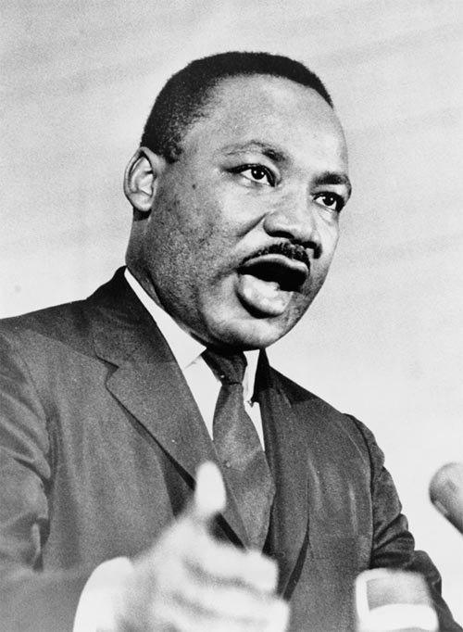
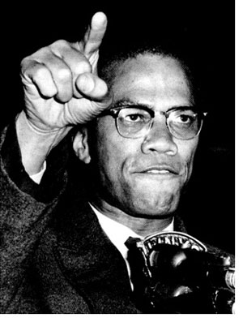
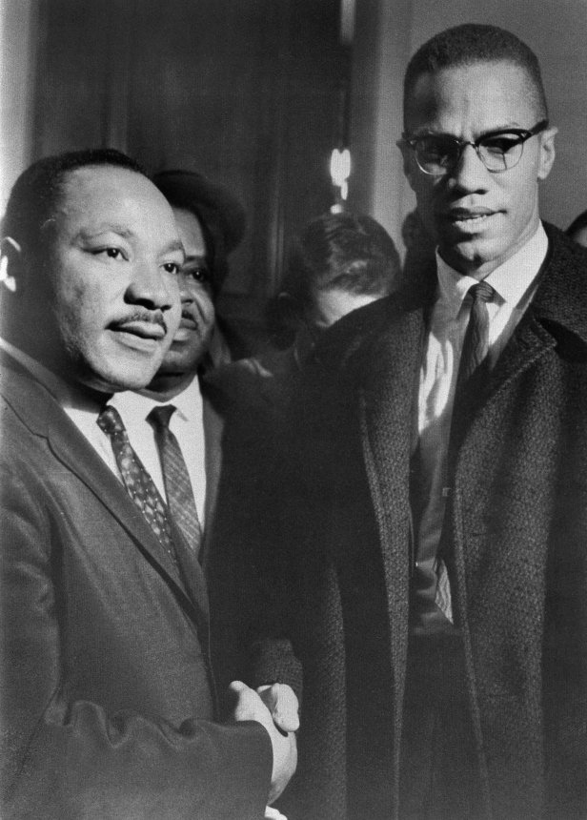
Malcolm X
Martin Luther King, Jr

ANSWER KEY

__X__ You can’t separate peace from freedom because no one can be at peace unless he has his freedom
_MLK___ Black men have slammed the door shut on a past of deadening passivity
_MLK___ I am convinced that if we are to get on the right side of the world revolution, we as a nation must undergo a radical revolution of values.
_X___ We can never get civil rights in America until our human rights are first restored. We will never be recognized as citizens until we are first recognized as humans.
_MLK___ There is a profound recognition of the need for man to overcome oppression without resorting to violence.
__X__ I don’t see how you could call the strides being made in the field of integration rapid when you don’t have one city in this country that can honestly say it is an example of sincere integration.
_MLK___ The only weapon we have in our hands is the weapon of protest…We will be guided by the highest principles of law and order.
_X___ But to do this, we must have land of our own. The brainwashed black man can never learn to stand on his own two feet until he is on his own.
__X__ Our goal is to bring about the complete independence of the people of African descent, in the Western Hemisphere and here in the United States, and to bring about the freedom of these people…by any means necessary.

The Impact of the Civil Rights Movement: An Analysis of MLK’s “I Have a Dream” Speech

Step 1: Read the following excerpt from Dr. Martin Luther King Jr.’s “I Have a Dream” speech from the March on Washington in 1963.

And so even though we face the difficulties of today and tomorrow, I still have a dream. It is a dream deeply rooted in the American dream. I have a dream that one day this nation will rise up and live out the true meaning of its creed: "We hold these truths to be self-evident, that all men are created equal."
I have a dream that one day on the red hills of Georgia, the sons of former slaves and the sons of former slave owners will be able to sit down together at the table of brotherhood. I have a dream that one day even the state of Mississippi, a state sweltering with the heat of injustice, sweltering with the heat of oppression, will be transformed into an oasis of freedom and justice.
I have a dream that my four little children will one day live in a nation where they will not be judged by the color of their skin but by the content of their character.
I have a dream today! I have a dream that one day, down in Alabama, with its vicious racists, with its governor having his lips dripping with the words of "interposition" and "nullification" -- one day right there in Alabama little black boys and black girls will be able to join hands with little white boys and white girls as sisters and brothers.
I have a dream today! I have a dream that one day every valley shall be exalted, and every hill and mountain shall be made low, the rough places will be made plain, and the crooked places will be made straight; "and the glory of the Lord shall be revealed and all flesh shall see it together."²
This is our hope, and this is the faith that I go back to the South with. With this faith, we will be able to hew out of the mountain of despair a stone of hope. With this faith, we will be able to transform the jangling discords of our nation into a beautiful symphony of brotherhood. With this faith, we will be able to work together, to pray together, to struggle together, to go to jail together, to stand up for freedom together, knowing that we will be free one day.
And this will be the day -- this will be the day when all of God's children will be able to sing with new meaning: My country 'tis of thee, sweet land of liberty, of thee I sing. Land where my fathers died, land of the Pilgrim's pride, From every mountainside, let freedom ring! And if America is to be a great nation, this must become true.
And so let freedom ring from the prodigious hilltops of New Hampshire. Let freedom ring from the mighty mountains of New York. Let freedom ring from the heightening Alleghenies of Pennsylvania. Let freedom ring from the snow-capped Rockies of Colorado. Let freedom ring from the curvaceous slopes of California.
But not only that: Let freedom ring from Stone Mountain of Georgia. Let freedom ring from Lookout Mountain of Tennessee. Let freedom ring from every hill and molehill of Mississippi. From every mountainside, let freedom ring.
And when this happens, when we allow freedom ring, when we let it ring from every village and every hamlet, from every state and every city, we will be able to speed up that day when all of God's children, black men and white men, Jews and Gentiles, Protestants and Catholics, will be able to join hands and sing in the words of the old Negro spiritual:
Free at last! Free at last! Thank God Almighty, we are free at last!

Step 2: Examine the following data about African Americans in the 1960s and 1970s AFTER the Civil Rights and Voting Rights Acts.

Document A
African American Voter Registration
Before and After Voting Rights Act of 1965
 | 1960 | 1966 | Percent Increase
Alabama | 66,000 | 250,000 | 278.8
Arkansas | 73,000 | 115,000 | 57.5
Florida | 183,000 | 303,000 | 65.6
Georgia | 180,000 | 300,000 | 66.7
Louisiana | 159,000 | 243,000 | 52.8
Mississippi | 22,000 | 175,000 | 695.4
North Carolina | 210,000 | 282,000 | 34.3
South Carolina | 58,000 | 191,000 | 229.3
Tennessee | 185,000 | 225,000 | 21.6
Texas | 227,000 | 400,000 | 76.2
Virginia | 100,000 | 205,000 | 105.0

Document B
Proportion of Families Below the Poverty Level
 | All Americans | African Americans
1959 | 18.5 | 48.1
1965 | 11.8 | 35.5
1971 | 10.0 | 28.8
1976 | 9.4 | 27.9
1981 | 11.2 | 30.8

Document C
African American Family Incomes, 1947 - 1974 (in 1974 dollars)
 | 1947 | 1974
Less than $3,000 | 42 | 14
$3,000 to $6,999 | 41 | 31
$7,000 to $9,999 | 9 | 16
$10,000 and more | 8 | 38

Document D
Proportion of Americans 25-29 Completing High School
 | All Americans | African Americans
1940 | 38.1 | 11.6
1950 | 52.8 | 22.2
1960 | 60.7 | 37.7
1970 | 73.8 | 55.4
1980 | 84.5 | 75.2

Document E
Percentage with four or more years of college
 | Blacks | Whites
1950 | 2.1 | 6.2
1981 | 8.2 | 17.8

Step 3: Answer the following discussion questions.
- From the “I Have a Dream” speech, identify 3 things that Dr. King “dreams” of for the future of America

- From the data on African Americans, to what extent was MLK’s dream a reality by the end of the 1970s? Provide at least 3 pieces of evidence to support your argument.

- To what extent is MLK’s dream a reality today? Provide at least 3 pieces of evidence to support your argument.

