[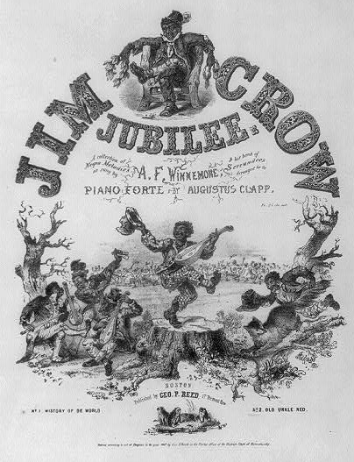](http://www.loc.gov/pictures/item/2001701399/)

**Jim Crow Jubilee Lithograph**

This image was included as the 1847 sheet music cover illustration for "A Collection of Negro Melodies as Sung by A. F. Winnemore & His Band of Serenaders. Arranged for the Piano Forte by Augustus Clapp." The sheet music was written for minstrel shows. According to Dictionary.com a minstrel show is "a popular stage entertainment featuring comic dialogue, song, and dance in highly conventionalized patterns, performed by a troupe of actors, traditionally comprising two end men and a chorus in blackface and an interlocutor: developed in the U.S. in the early and mid-19th century." In other words, minstrel shows were musical and theatrical productions performed by whites who painted their faces black so that they looked like African American slaves. These shows were meant to entertain white audiences by making fun of black slaves, and the songs and dances that black slaves performed as part of their entertainment and religious traditions. This image depicts African Americans as worry-free and slap-happy people. However, the lives of freedmen and slaves were far from such a reality. The image also depicts the racist stereotypes of blacks by whites in the nineteenth century. This image is important as it contextualizes the early interpretation of "Jim Crow" in the mid-1800s. That is, "Jim Crow" was first used to describe the happy-go-lucky caricature of African Americans and the minstrels show genre that made fun of African Americans. The term "Jim Crow" gained popularity and was used after Reconstruction in the 1880s, 1890s, and early 1900s to refer to the segregation laws which mandated that whites and blacks be separated in public spaces.

**!. What is a minstrel show and who performed in these shows?**

**2. What is blackface?**

**3. What was the name of the character in these minstrel shows?**

**4. What was the purpose of the minstrel show?**

**5. How was the character’s name used later?**

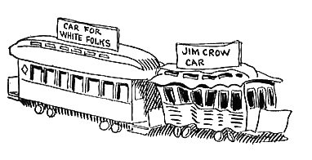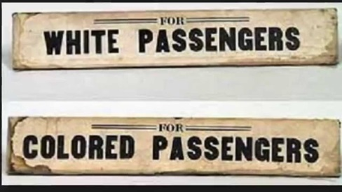

The Jim Crow laws still dominated race relations in the South in 1912. In the following essay from 1912 a columnist for the African-American paper *The Indianapolis Recorder* describes the practice and principles behind Jim Crow laws.

THE JIM CROW CAR.

How the Democratic Legislators of the South Endeavor to Degrade and Humiliate the Afro-American.

In their efforts to degrade and humiliate the race the Democratic legislators of every southern state have provided a system of Jim Crow cars for Afro-Americans. The Iaws say that the accommodations "shall be equal, but separate." As a matter of fact, they are seldom equal and usually very inferior, especially on the smaller lines. where worn-out cars. which are generally In a filthy condition, are for Afro-Americans. On the larger roads better cars are used, but the Jim Crow car is generally placed next to the locomotive. where the occupants get the full benefit of the dust and smoke and are in a dangerous position In case of accident. Several states have enacted laws forbidding sleeping car companies to sell berths to Afro-Americans. These laws were not passed for the reason that southern Democrats are anxious to avoid close proximity to Afro-Americans, for servants are allowed under the law to ride in the same car with the whites. The Idea, which is to humiliate the race, is clearly expressed by H. D. Wilson. a prominent Louisiana Democrat, greatly Interested in Jim Crow legislation. who said: "It is not only the desire to separate the whites and blacks on the railroad for the comfort it will provide, but also-for the moral effect. The separation of the races is one of benefit, but the demonstration of the superiority of the white man over the Negro is a greater thing. There is nothing which shows it more conclusively than the compelling of Negroes to ride in cars marked for their especial use."

1. What are “Jim Crow cars”?
2. Looking at Jim Crow cars how did southern states violate the doctrine of separate but equal?
3. What was the overall goal of Jim Crow Laws?