**Chapter 20 Review**

1. In 1960 voters were concerned about JFK’s ____________ & ____________.
2. JFK won the 1960 election partly because of his performance on _________ & his _________.
3. 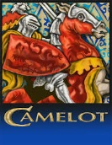 Explain JFK’s connection to this mythical place.
4. 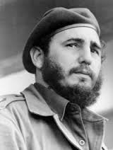 Who is this man? What event did his rise to power lead to?

Why?

1. 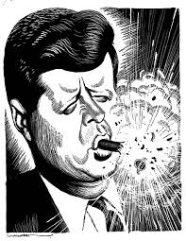What event is the cartoon portraying?

Explain how.

1. 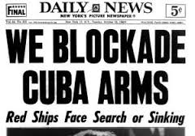What event is this headline associated with?

Explain how?

1. 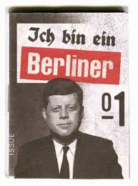Where was Kennedy when he spoke these words?

Why was he there?

What was his message to the people there?

1. 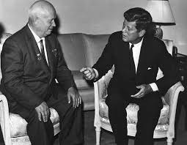 What two things did these two men establish to ease Cold war tensions?

What did each do?

1. Below each date explain the major event that occurred during the Space Race.

10/1957 4/1961 5/1961 7/1969

Who won the space race? How do you know?

1. What was JFK’s military policy called?

Why did JFK adopt a new military policy different from Eisenhower’s?

1. What was JFK’s New Frontier:

-Major domestic issues focused on?

-2 foreign programs created?

1. 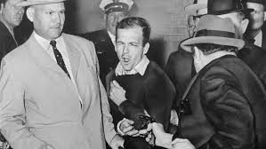 Explain the role & importance of the people in this picture.
2. 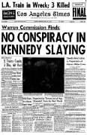 What source was this headline based on?
3. What does EOA stand for?

-What did LBJ declare a war on?

-Which program created by the EOA would have been helpful to you as a child?

-Which program was called the domestic Peace Corps?

1. How did the threat of nuclear war help LBJ in the 1964 election?
2. 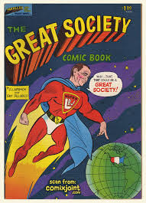 Who is portrayed as a superhero?

- What two issues was he going to fight to end?

1. 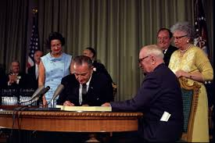 Which Great Society program is LBJ most likely signing into law?

-What evidence do you have?

1.  Which Great Society program would this picture most likely represent? Why?
2. Give an example of another Great Society law/Act passed to improve America. What did it do?
3. Provide an example of how one decision of the Warren Court would help you if you were accused or suspected of a crime. Give the name of the case & how it would help protect your rights.