**Sons of Liberty**

**Bell Work #1**: Read the synopsis for episode #1 then use your computer to define the following terms. Place your work on this sheet.

**Sons of Liberty: Episode 1: A Dangerous Game**

Sons of Liberty opens in 1765 when new taxes on the American colonies enacted by the British government have started to stir major unrest among citizens. Cousins John and Sam Adams, and John Hancock, one of the richest men in Boston, are among those who become very concerned about the consequences of these policies. Anger among Bostonians reaches a breaking point. Governor Thomas Hutchinson’s mansion is ransacked by angry citizens. Hancock is infuriated when his sloop Liberty is confiscated by officials. Bostonians are left in shock in February 1770 when a young boy named Christopher Seider is killed after a protest escalates into chaos. Weeks later, tensions explode, leading to a bloody confrontation later known as the Boston Massacre.

**Customs-**

**Duties-**

**Prudent-**

**Lucrative-**

Inevitable-

**Tory-**

**Loyalist-**

**Boycott-**

**Answer during episode #1:**

**Main Characters:**

1. Why were Sam Adams and John Hancock frustrated with government policies in the mid-1760s?
2. Why was John Adams nervous about the escalating protests in Boston?
3. The character Kelly tells a story in this episode about his family’s loss of property. How do you think these changes in economic status affected colonists like Kelly?
4. What were some of the reasons tensions in Boston escalated between 1765 and 1770?
5. By 1770, do you think anyone would have predicted that revolution was inevitable?
6. **Bell Work #2-Look at Paul Revere’s engraving and read the words he wrote underneath it. Then answer the following questions.**

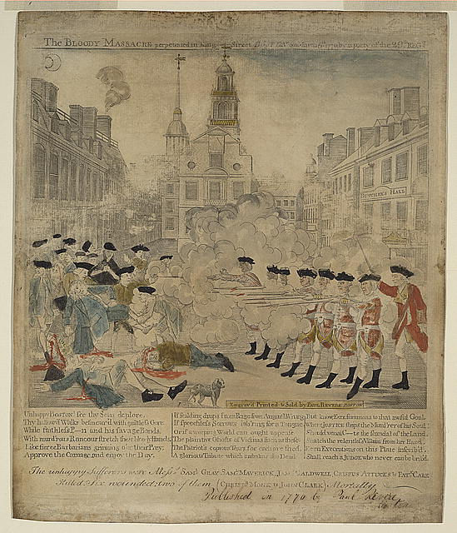

Unhappy BOSTON! see thy Sons deplore, Thy hallowe'd Walks besmear'd with guiltless Gore: While faithless—and his savage Bands, With murd'rous Rancour stretch their bloody Hands; Like fierce Barbarians grinning o'er their Prey, Approve the Carnage, and enjoy the Day. If scalding drops from Rage from Anguish Wrung If speechless Sorrows lab' ring for a Tongue, Or if a weeping World can ought appease The plaintive Ghosts of Victims such as these; The Patriot's copious Tears for each are shed, A glorious Tribute which embalms the Dead. But know, FATE summons to that awful Goal, Where JUSTICE strips the Murd'rer of his Soul: The unhappy Sufferers were Messs. SAM. L GRAY, SAM.L MAVERICK, JAM.S CALDWELL , CRISPUS ATTUCKS & PAT.K CARR Killed. Six wounded two of them (CHRIST.R MONK & JOHN CLARK) Mortally

**Bell Work #2 Questions:**

1. How would you describe the words on Revere’s engraving?
2. What is his main message?
3. Why do you think Revere created this engraving?

**Bell Work #3**: Read the synopsis for episode #2 then use your computer to define the following terms. Place your work on this sheet.

**Sons of Liberty: Episode 2: The Uprising**

Despite the concerns of John Hancock and others that protests in Boston were going too far, Sam Adams, Paul Revere, Dr. Joseph Warren and others continue to mobilize against the unfair policies of the British government. At the “Boston Tea Party” in December 1773, colonists risk their reputations and safety, destroying hundreds of crates of British tea in Boston Harbor to show their profound discontent. In response to this act of insubordination, the king escalates military presence. The Sons of Liberty know this means only one thing: they must unite the colonies against the British oppression. Representatives from the colonies meet at the First Continental Congress, including the military leader George Washington. Meanwhile, a silversmith named Paul Revere has joined the fight for liberty. The story of his courageous ride to Lexington to warn John Hancock and Sam Adams that British troops were coming to arrest them would make him a legend.

**Insubordinate-**

**Tyranny-**

**Billet-**

**Due Process-**

**Oppression-**

**Munitions-**

**Complete during episode #2:**

**Main Characters:**

1. **Use examples from the episode to explain how the Quartering Act helped push the colonists towards revolution.**
2. **Explain how the Committees of Correspondence helped the colonies communicate with one another.**
3. **Describe the contributions of at least two African-Americans during the Revolutionary era.**
4. **Describe the importance of Paul Revere’s ride and explain who the other riders were and their routes.**

**Bell Work #4: Read the letter below and answer the questions that follow.**

Primary Source: Right after the Boston Tea Party John Adams wrote to his friend James Warren, recording his view of the protest

To James Warren Boston Decr 17 1773

Dr Sir The Dye is cast: The People have passed the River and cutt away the Bridge: last Night Three Cargoes of Tea, were emptied into the Harbour. This is the grandest, Event, which has ever yet happened Since, the Controversy, with Britain, opened! The Sublimity of it, charms me! For my own Part, I cannot express my own Sentiments of it, better than in the Words of Coll Doane to me, last Evening—Balch Should repeat them—The worst that can happen, I think, Says he in Consequence of it, will be that the Province must pay for it. Now, I think the Province, may pay for it, if it is burn'd as easily as if it is drank—and I think it is a matter of indifference whether it is drank or drowned. The Province must pay for it, in Either Case. But there is this Difference. I believe, it will take them 10 Years to get the Province to pay for it. If so, we shall Save 10 Years Interest of the Money. Whereas if it is drank it must be paid for immediately. Thus He—However, He agreed with me that the Province, would never pay for it. And also in this that the final Ruin, of our Constitution of Government, and of all American Liberties, would be the certain Consequence of Suffering it to be landed. Governor Hutchinson and his Family and Friends will never have done, with their good services to Great Britain and the Colonies! But for him, this Tea might have been Saved to the East India Company. Whereas this Loss if the rest of the Colonies Should follow our Example, will in the opinion of many Persons bankrupt the Company. However, I dare Say, that the Governors, and Consignees, and Custom House Officers, in the other Colonies will have more Wisdom than ours have had, and take effectual Care that thier Tea shall be sent back to England untouched. If not it will as surely be destroyed there as it has been here. Threats, Phantoms, Bugbears, by the million, will be invented and propagated among the People upon this occasion. Individuals will be threatened with Suits and Prosecutions. Armies and Navies will be talked of—military Execution—Charters annull'd—Treason—Tryals in England and all that—But—these Terrors, are all but Imaginations. Yet if they should become Realities they had better be Suffered, than the great Principle, of Parliamentary Taxation given up. The Town of Boston, was never more Still and calm of a Saturday night than it was last Night. All Things were conducted with great order, Decency and perfect Submission to Government. No Doubt, we all thought the Administration in better Hands, than it had been. Please to make Mrs Adams's most respectfull Compliments to Mrs Warren and mine.

I am your Friend, John Adams

1. Based on this letter, do you think John Adams approved of the Boston Tea Party? Why or why not?

2. What does Adams think the consequences of the Tea Party might be?

**Bell Work #5**: Read the synopsis for episode #3 then use your computer to define the following terms. Place your work on this sheet.

**Sons of Liberty: Episode 3: Independence**

As the rebels face off against the Redcoats at Lexington and Concord in April and Bunker Hill in June 1775, war is starting to seem like the only viable path to liberty. The British lock down the city and prepare for all-out war. What started as a series of protests in Boston is evolving into a revolution against British power. Key leaders of the rebellion travel to Philadelphia for the Second Continental Congress, hoping to convince the rest of the colonies that the time is now to rally for independence. George Washington is made head of the Continental Army while British General Gage sends for additional warships and troops. For Sam Adams and the rest of the Sons of Liberty, it is now or never. The fate of the country comes down to one final vote during the summer of 1776. It is a vote that changes everything: a vote for independence.

**Treason-**

**Militia-**

**Alleviate-**

**Stalemate-**

**Colonist-**

**Trepidation-**

**During Episode #3**:

**Main Characters:**

1. **Explain the use of the phrase “Join or Die” as used by the patriots during the revolutionary era.**

**-If you were alive during this time, explain how you would have responded to this statement.**

1. **Why did the colonists feel the need to write the Declaration of Independence?**

**-Would you have signed it knowing the consequences of doing so? Explain your decision.**

1. **In the space below, create a DVD cover with a subtitle for the show *Sons of Liberty*.**
2. **Bell Work #6:** Read the letter below and then answer the questions that follow.

Primary Source: : Letter from Abigail Adams to John Adams Throughout their lives, Abigail and John Adams exchanged hundreds of letters. In this letter written on June 18, 1775, Abigail Adams discusses the death of Dr. Joseph Warren and the battle of Bunker Hill.

Dearest Friend Sunday June 18 1775

The Day; perhaps the decisive Day is come on which the fate of America depends. my bursting Heart must find vent at my pen. I have just heard that our dear Friend Dr. Warren is no more but fell gloriously fighting for his Country-saying better to die honourably in the field than ignominiously hang upon the Gallows. great is our Loss. He has distinguished himself in every engagement, by his courage and fortitude, by animating the Soldiers & leading them on by his own example -- a particular account of these dreadful, but I hope Glorious Days will be transmitted you, no doubt in the exactest manner. The race is not to the swift, nor the battle to the strong -- but the God of Israel is he that giveth strength & power unto his people. Trust in him at all times ye people pour out your hearts before him. God is a refuge for us. --Charlstown is laid in ashes. The Battle began upon our intrenchments upon Bunkers Hill, a Saturday morning about 3 oclock & has not ceased yet & tis now 3 o'clock Sabbeth afternoon. Tis expected they will come out over the Neck to night, & a dreadful Battle must ensue Almighty God cover the heads of our Country men, & be a shield to our Dear Friends. how [many ha]ve fallen we know not-the constant roar of the cannon is so [distre]ssing that we can not Eat Drink or Sleep -- may we be supported and sustaind in the dreadful conflict. I shall tarry here till tis thou[ght] unsafe by my Friends, & then I have secured myself a retreat at your Brothers who has kindly offerd me part of his house. I cannot compose myself to write any further at present -- I will add more as I hear further—

Letter from Abigail Adams to John Adams, 18 - 20 June 1775 [electronic edition]. Adams Family Papers:

1. How does Abigail Adams describe Dr. Joseph Warren in her letter?

2. How does she describe what life was like in Boston after the Battle of Bunker Hill?

3. Based on her letter, how would you describe her feelings about the onset of the war?