Fighting World War II in Europe & North Africa: 1941-1945

I. From 1939 to 1942, the Axis Powers dominated Europe, North Africa, & Asia
A. In Europe
1. Germany used ____________________ tactics to dominate Eastern & Western Europe
2. England was wounded from German attacks in the _______________________________________
3. Hitler broke the __________________________________ Nonaggression Pact & marched into ___________________
B. The German & Italian armies dominated Northern Africa, threatened the __________________________ & the ________ fields in the Middle East
C. The ______________________ dominated Asia, crippled the U.S. navy after the ___________________________________ attack, & seized most Western colonies in the Pacific
II. However, U.S. entrance into the war in 1941 helped the Allies turn the tide and defeat the Axis by 1945
A. The Battle of the Atlantic
1. FDR & Churchill agreed that ___________________________________________ was the top priority, but American troops would be deployed to fight _____________________ at the same time
2. To win in Europe, the U.S. had to secure the ____________________________________ supply lines against German submarines
3. The Allies won the Battle of the Atlantic by breaking Germany’s _____________________________________________________
B. North Africa & the Italian Campaign
1. When the USA entered WWII, Stalin wanted the Allies to open a __________________________________ & divide German army
2. Instead, Britain & USA agreed to fight the Axis Powers in ____________________________________ (Stalin was _____________)
3. The Allies defeated Germany at the Battle of __________________________ in 1942 & then pushed the Axis Powers out of Africa
4. American & British troops invaded ________________, took Sicily in 1943, seized Rome in 1944
5. In 1945, Mussolini was ____________________ & ________________________ by the Italian resistance
C. The Soviet Union & the Eastern Front
1. Meanwhile, the Soviet army stopped the German attack at Moscow & Leningrad in 1942
2. The Battle of Stalingrad
a. The Soviets defeated the German army at the ________________________________________________
b. The Soviet victory at Stalingrad was a _________________________________ in World War II because the Russians began pushing towards _______________________ from the East by 1943
D. Operation Overlord (D-Day)
1. By 1944, the Allies decided to open a __________________________________ by invading Nazi-occupied ___________________
2. Operation Overlord (called _________________) in June 1944 was the _________________________ land & sea attack in history
3. The ___________________________ invasion was deadly, but the Allied victory created a Western Front…and allowed the Allies to push towards _____________________________ from the West
4. At the same time, the _________________________________________ pushed from the East
b. Forced to fight a ____________________ war, Hitler ordered a massive counter-attack at the Battle of the Bulge…but ______
c. By March 1945, the Allies were fighting in Germany & pushing towards _____________________
E. In February 1945, the “Big Three” met at the ____________________ Conference to create a plan for Europe after the war was over
1. Stalin agreed to send troops to help the U.S. ______________________________________
2. They agreed to allow __________________________________________________ (free elections) in nations freed from Nazi rule
3. They agreed to ____________________________________________________ after the war
4. They agreed to create & join a ____________________________________________
F. As the Allies pushed into Germany & Poland, troops discovered & liberated concentration & _________________________________
G. Victory in Europe
1. In April 1945, the Soviet army _____________________________ Berlin
2. On April 30, 1945, Hitler committed __________________________
3. On May 8, 1945, the German government signed an unconditional _________________________ to the Allies
4. The world celebrated _____________________ May 8th, 1945.
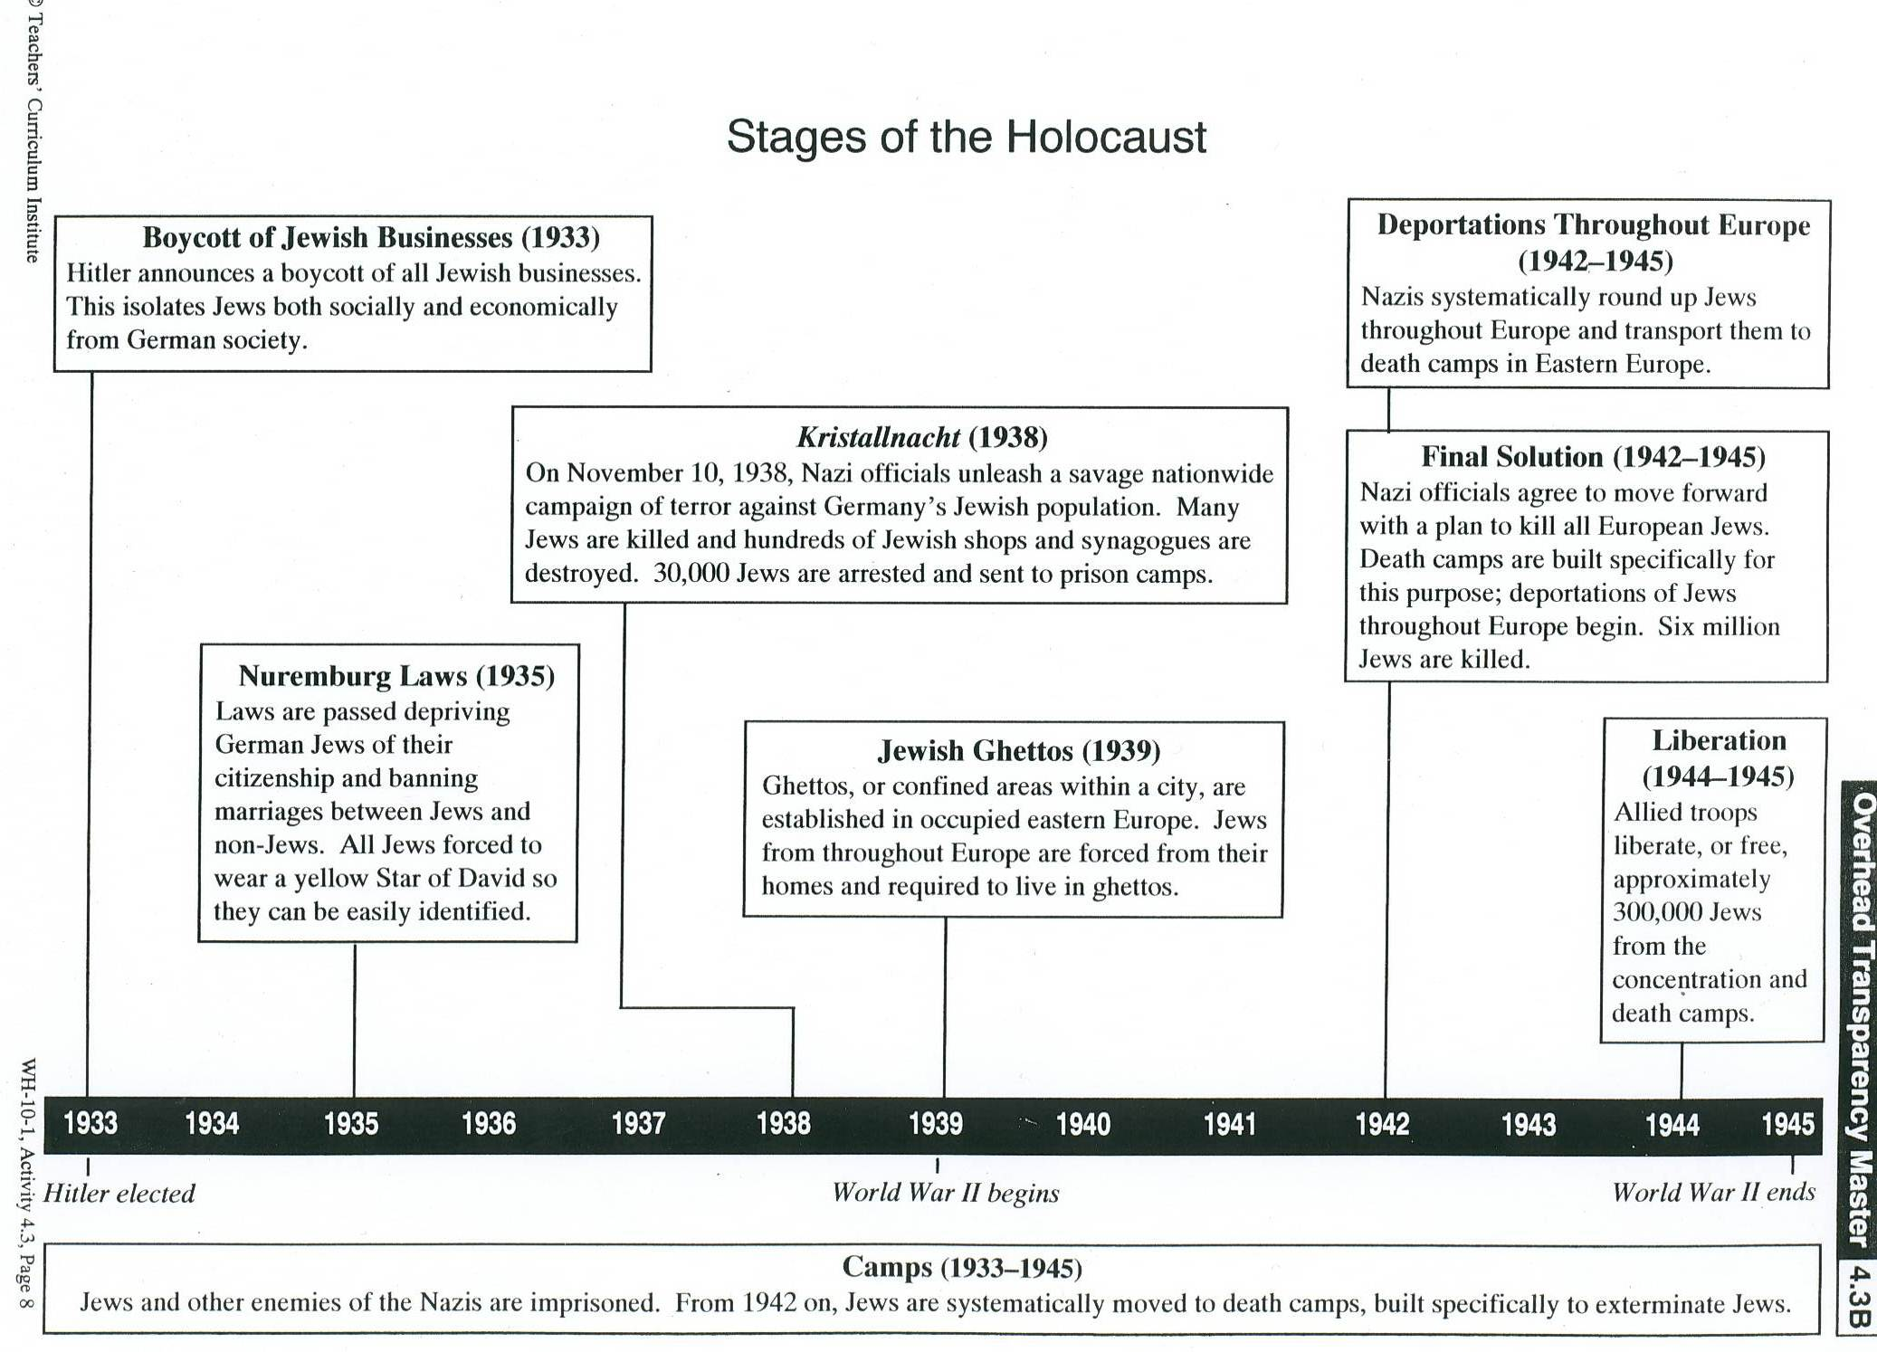
The U.S. Response to the Holocaust
President Roosevelt: In July 1942, Jewish leaders began trying to bring to President Franklin Roosevelt’s attention reports of German atrocities against Jews. However, these reports were suppressed by the State Department and never reached the president. On September 3, 1942, Jewish citizens in Switzerland sent the following telegram to FDR:
According to numerous authentical information from Poland, German authorities have recently evacuated the Warsaw ghetto and bestially murdered about one hundred thousand Jews. The mass murders are continuing. The corpses of the murdered victims are used for the manufacture of sap and artificial fertilizers. Similar fate is awaiting the Jews deported to Poland from other occupied territories. Suppose that only energetical steps from America my stop these persecutions.
FDR did not respond to the letter. In November 1942 information proving that the Nazis were seeking to systematically exterminate European Jews was made public in the United States. In 1944, FDR created the War Refugee Board (WRB) to save Jews and other victims of the “Final Solution.” Led mostly by Jewish organizations in the U.S., the WRB saved approximately 200,000 Jews and 20,000 non-Jewish Europeans.
The American Public: During World War II, anti-Semitism (anti-Jewish feelings) was high. After the violence of Kristallnacht in 1939, 42.3% of Americans believed that the violence in Germany was caused because of “unfavorable characteristics” of the Jewish people. Americans ranked Jews second only to Italians as the group considered to be the worst citizens. In 1943, more than half of Americans did not believe reports that the Nazis were deliberately killing Jews. International news services, such as the Associated Press and United Press, delivered extensive information about the Holocaust to U.S. newspapers. However, most newspapers and magazines printed very little about the Holocaust. Americans were opposed to allowing Jewish refugees from Europe to enter the United States. In 1939, the German ship, St. Louis, arrived in Miami with 943 European Jews. Of these passengers, 740 had legal immigration papers to enter the country. The Coast Guard refused to allow any passenger from embarking in America and the ship returned to Europe. More than half of these passengers later died in the Holocaust.
The U.S. Military: As the Americans gained air supremacy over Germany in 1944, the U.S. War Department rejected several appeals to bomb the gas chambers and railroads leading to the Auschwitz death camp in Poland, claiming that such action would divert essential airpower from important military operations elsewhere. The War Department issued the following statement in response to pleas from American Jews to liberate the death camps and concentration camps in Europe:
The War Department fully appreciates the humanitarian importance of suggested [bombing] operation. However, after due consideration of the problem, it is considered that the most effective relief to victims of enemy persecution is the early defeat of the Axis, an undertaking to which we must devote every resource at our disposal.
Instead the War Department began bombing industrial centers surrounding Auschwitz beginning in August and September 1944. These bombing missions made no attempt to strike the killing centers. If the gas chambers had been targeted at this late stage in the war, it would have been practically impossible for the Germans to rebuild them. Available figures indicate that 100,000 Jews were gassed at Auschwitz between August 1944 and January 1945 when the camp was liberated by the Soviet army.
- Why do you think more was not done to help the situation?
- What could or should have been done differently by (a) the president? (b) the media? (c) the military?
- Do you agree that the best way to help European Jews was to win the war quickly? Or do you think the U.S. should have prioritized humanitarian efforts to help Jews even if it meant that the war went on longer?

