**Series and Parallel Circuit Lab Simulation**

**Objective:** To investigate the properties of series and parallel circuits.

**Link:** Visit the PhET circuit construction kit simulation: <https://phet.colorado.edu/en/simulation/circuit-construction-kit-dc> and choose **Intro**.

**Part 1: Pre Lab**

1. What are the 3 basic parts of a circuit? _________________________________________________________________________________
2. What are 2 sources of resistance in a circuit? (Assuming the battery has no internal resistance). _________________________________________________________________________________
3. Consider the pictures of each of these circuits, then answer the questions below.

**Series Circuit Parallel Circuit**

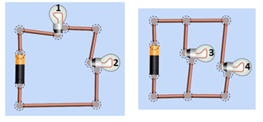

1. What do we mean by the flow of charge in a circuit? Which type of circuit allows for multiple pathways for charge to flow? ______________________________________________________________________________________________________________________________________________________
2. From the circuits above, predict which bulb (or bulbs) will be the brightest. Why do you think that is the case?

______________________________________________________________________________________________________________________________________________________

**Part 2: Explore the simulation**

1. Explore the simulation and place a check mark in the boxes below once you complete this step.
2. ⬜ Build a simple circuit and figure out how to make a light bulb light up.
3. ⬜ Figure out how to measure current and voltage. (Hint: Find the voltmeter and ammeter).

**Part 3 – Building a simple, series and parallel circuit**

1. Build a **simple circuit** using a battery, switch, connecting wires and 1 light bulb. Draw or paste a picture of the circuit diagram in the box below.
2. What happens when you open the switch? Why do you think that is the case?

_________________________________________________________________________________

1. Build three **series circuits** with the following amounts of light bulbs using the PhET simulation. Remember in a series circuit, there is only on path for charges to flow. Keep the battery source the same. Describe the flow of electron in each circuit and rank the relative brightness in your table.

|  |  |  |
| --- | --- | --- |
| **Number of Light Bulbs** | **Describe the path of electron flow (ex. How many paths)** | **Relative brightness of bulbs based on the length of the light rays (Use words like same brightness, brightest, least bright).** |
| **1** |  |  |
| **2** |  |  |
| **3** |  |  |

1. What happens to the brightness of the bulbs as you add more bulbs in series? Why do you think this is the case? _________________________________________________________________________________

_________________________________________________________________________________

1. What happens to the other bulbs in the circuit when you make a break in the circuit by disconnecting one light bulb? Why do you think this is the case? _________________________________________________________________________________

_________________________________________________________________________________

1. Fill in the table below for a series circuit with 3 resistors (R) by using the **voltmeter** and **ammeter** to measure voltages and currents in the circuits. Click on the values box in the top right corner of the screen to fill in the values for the resistance.

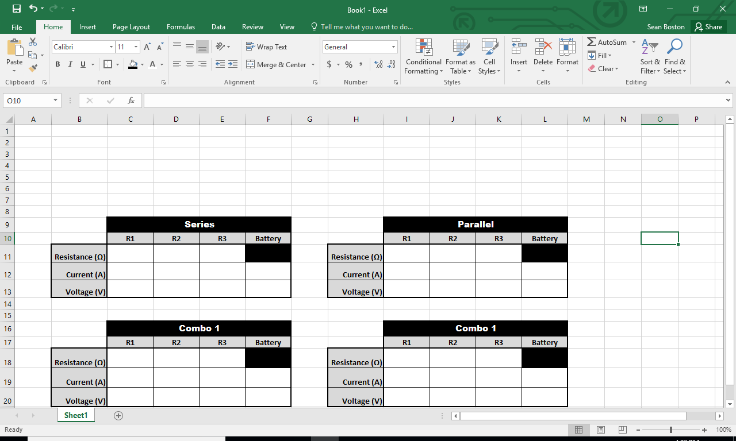

1. What patterns stand out about the currents? Why does this happen?

______________________________________________________________________________

1. What do you notice about the voltages used by the lightbulbs/resistors to the voltage of the battery?

______________________________________________________________________________

1. Build three **parallel circuits** with the following number of light bulbs and rank the relative brightness of the bulbs. Remember, in a parallel circuit there are multiple pathways for charges to flow. Keep your battery source the same. Describe the path of electron in each circuit and rank the relative brightness in your table

|  |  |  |
| --- | --- | --- |
| **Number of Light Bulbs in Parallel** | **Describe the path of electron flow (ex. How many paths)** | **Relative brightness of bulbs based on the length of the light rays (Use words like same brightness, brightest, least bright).** |
| **1** |  |  |
| **2** |  |  |
| **3** |  |  |

1. What happens to the brightness of the bulbs as you add more bulbs in parallel? Why do you think this is the case? __________________________________________________________________________________________________________________________________________________________________
2. What happens to the other bulbs in the circuit when you make a break in the circuit by disconnecting one light bulb? Why do you think this is the case? __________________________________________________________________________________________________________________________________________________________________
3. Fill in the table below for a parallel circuit with 3 resistors by using the voltmeter and ammeter to measure voltages and currents in the circuits. Click on the values box in the top right corner of the screen to fill in the values for the resistance.



1. What patterns stand out about the voltages? Why does this happen?

_____________________________________________________________________________

1. What do you notice about the current used by the lightbulbs/resistors to the current of the battery?

______________________________________________________________________________

**Part 4- Conclusion Questions**

1. Series vs. Parallel Circuits:
2. Explain the difference between the circuits below using academic words.

__________________________________________________________________________________________________________________________________________________________________

__________________________________________________________________________________________________________________________________________________________________

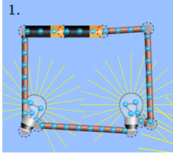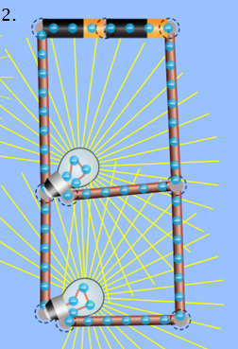

1. What stays the same everywhere in a series circuit? Parallel circuit?

___________________________________________________________________________________________________________________________________________________________________________________________________________________________________________________

1. What is divided proportionally in a series circuit? Parallel circuit?

___________________________________________________________________________________________________________________________________________________________________________________________________________________________________________________

1. What do you think are advantages and disadvantages of series and parallel circuit?

___________________________________________________________________________________________________________________________________________________________________________________________________________________________________________________