April 24, 2020

Greetings,

Since our school buildings closed on Friday, March 13th there have been thousands of positive interactions between students and teachers via phone, e-mail, and on-line. This is why I am so deeply troubled and concerned about a few individuals who have taken advantage of our new school environment, made poor choices, and become disruptive to the learning process.

These disruptions occurred at the middle school level while teachers were trying to provide instruction to students during a Google Meeting. Unfortunately, these disruptions crossed a line and became threatening and obscene. It has also been discovered that, in some cases, students willingly gave their user information and password to these individuals allowing them to gain access to the meetings. Students are responsible to protect the confidentiality of their district issued accounts and passwords. It is a direct violation of district guidelines and protocol to share passwords with anyone and we will not tolerate those violations as we ensure the security of our network in order to protect our students.

The behaviors that these students exhibited are not acceptable at any time but especially now, as we all deal with a worldwide crisis, the district will not permit this type of disruption to learning. It is our responsibility to protect instruction and we will be enforcing every disciplinary action allowed by our Student Code of Conduct. For those individuals who violated the law, we will involve the Dearborn Police to issue tickets, and if needed, take further and more serious legal action.

Although teachers and students have been safely using Google Meetings, I asked our Instructional Technology Department to temporarily suspend all student access to Google Meeting on the District network. We are also working to have staff use a platform for on-line meetings that has been used in the District for several years and is specifically developed for use in the classroom. The software gives teachers more control over a meeting including ending if someone attempts to gain access without permission.

I proudly started my career as a teacher and, like many of you, my wife and I are also adjusting to working at home and supporting the learning needs of one middle school and one high school aged child. The actions that took place this week disrespects the efforts that all of you are doing to support your child's education. As Superintendent, and as a father, I am sorry this occurred and apologize to the students who were the victims of these behaviors.

Just as my wife and I have taken an active role in our own children's learning and on-line activities, I ask all parents to use this experience as an opportunity to talk with your child about proper behaviors while on-line including protecting your personal information such as usernames and passwords.

Since March 16th, I have heard many encouraging stories of student learning taking place at all grade levels. This past week has been a shift for all of us as we transitioned to the new learning plan. Of course there has been a learning curve for everyone involved including staff, students, and parents. We understand this transition to “Continue the Learning” is going to create frustrations and questions. Please know that our teachers, principals, and administrators are here to help all of our families during the weeks ahead. Our continued goal is to be supportive during this very difficult time. Remember, we are all in this together and together we will become an even stronger Dearborn community.

Stay home. Stay safe. Save lives.

Regards,

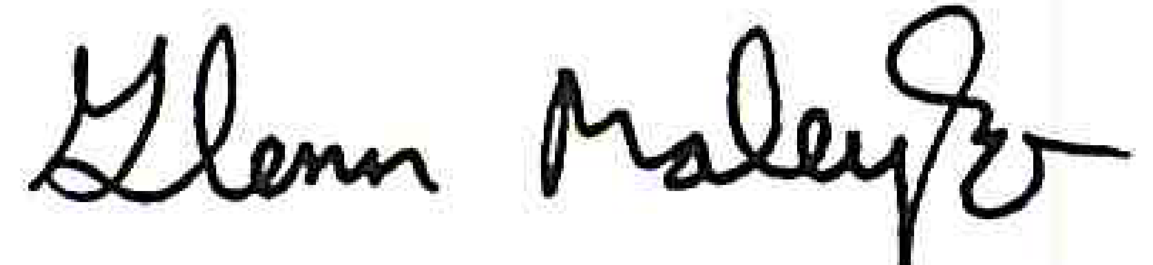

Glenn Maleyko, Ph.D.

Superintendent