Double Entry Journal
Question | Response
Section 31.2
- When does diffraction happen? Does the spreading become more or less pronounced for narrower openings?

- What is this spreading called?
- 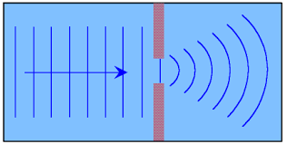

- Does it help or hurt radio reception for radio waves to be so big? Why?

- What kind of waves diffract easier?

Section 31.3
- Is it possible for a wave to make another wave smaller?...cancel it out? Defend your claim.

Section 31.5
- What is iridescence? What are some real world examples?

- When we see a colorful oil spot, do we see colors that constructively interfere, or destructively interfere? Why?

- Why is gasoline that is spilled on a wet surface so colorful?
Complete the following:
_________________ involves a change in direction of waves when they bounce off a barrier.
_________________ involves a change in direction of waves as they change mediums.
_________________ involves a change in direction of waves as they pass through an opening or around
an object.

