Station 1- Work

- If you exert 1550 N to do 2100 J of work on a refrigerator, how far did you move it? (1.4 m)
- A child does 505 J of work to pull a sled up a hill. If the child walks 18 m up the hill, what force is required? (28.05 N)
- You must exert a force of 8.5 N on a book to slide it across a table. If you do 6.7 J of work in the process, how far have you moved the book? (0.78 m)
- How much work is done when you lift a 34 kg mass 7 m? (2380 J)
- How much work is done on a car if a 5150 N force is exerted to move it 85.5 m to the side of the road? (440,325 J)
- How much force is necessary to push a car 9.2 m and do 14,500 J of work? (1,576.08 N)
- A crate is being lifted into a truck. If it is moved with a 2860 N force and 3050 J of work is done, how far has the crate been lifted? (1.06 m)
- If 18,700 J of work is done to shoot the human cannonball down a 3 m barrel, then how much force is applied to the person to fire them out the cannon? (6,233.3 N)
- An elephant pushes with 2640 N on a load of trees for 190 m. How much work did the elephant do? (501,600 J)
- If you do 980 J of work to lift a book 4 m, how much force was required? (245 N)

Create the following bracemap on a separate sheet of paper and fill it out as you rotate between stations:
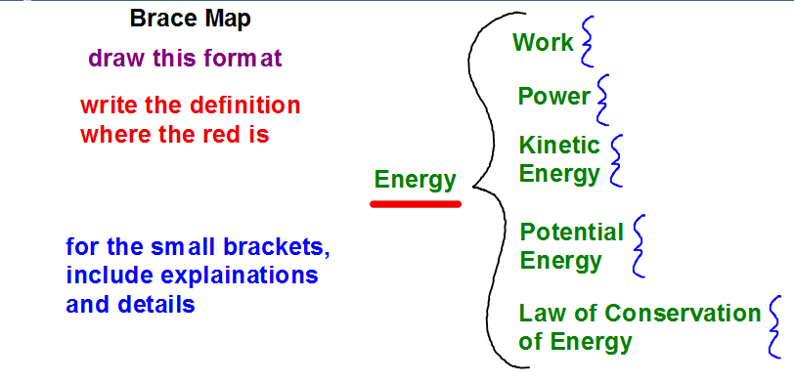

Station 2- POWER

- How much power is needed to do 508 Joules of work in 100 seconds? (5.08 W)
- How long does it take to do 658 Joules of work with 28 watts? (23.5 s)
- If 460 watts of power is used in 32 seconds, how much work was done? (14,720 J)
- How much work was done if you use 100 W for 500 s? (50,000 J)
- How much time is needed to do 6.2 J of work with 1.2 W of power? (5.16 s)
- How much power does it take to do 940 J of work in 5 s? (188 W)
- How long does it take to do 386 J of work with 18 watts? (21.44s)
- How much power is used to do 520.8 J of work in 350.2 s? (1.48 W)
- If a runner exerts 450 J of work to make 135 W of power, then how long did it take to do that work? (3.33 s)
- If you light a 60 W light bulb for 8.2 s, how much work did you do? (492 J)

Create the following bracemap on a separate sheet of paper and fill it out as you rotate between stations:

Station 3: Potential Energy: PE = mgh or PE=wh
- What is the PE of a 4 kg block 35 m above the floor? (4900 J)
- What is the PE of a 8 kg ball 2.5 m above the floor? (200 J)
- What is the PE of a 19.3 kg rock on a 2.2 m ledge? (424.6 J)
- What is the PE of a 855 N person on a 8.4 m roof? (7182 J)
- How much PE would a rock have on a 150 m cliff if it weighs 80 N? (12000 J)
- How much PE would a bird that weighs 20 N have sitting on a branch 15 m off the ground? (300 J)
- Joe throws a 8 kg stone straight up and it reaches 5 m. What is the PE at the highest point? (400 J)
- Which has more PE 2 m off the floor: 6 kg of feathers or 6 kg of rocks? Show/explain your answer. (same)
- Which has more PE: a 8 kg ball 5 m up or a 6 kg rock 5 m off the floor? Show/explain your answer. (ball)
- Which has more PE: a 3.5 kg book at 6 meters or a 12 kg paperweight at 8 m? Show/explain your answer. (paperweight)

Create the following bracemap on a separate sheet of paper and fill it out as you rotate between stations:

Station 4
Kinetic Energy: KE=mv² OR KE = ½ mv²
2
- What is the KE of a 5 kg mass at 4 m/s? (40 J)
- What is the KE of a 6 kg mass at 4 m/s? (48 J)
- What is the KE of a 3.5 kg mass at 8.2 m/s? (117.67 J)
- What is the KE of a 4.6 kg mass moving at 11.9 m/s? (325.70 J)
- What has more KE: a 5 kg mass at 5 m/s or a 2 kg mass at 4 m/s? Show/explain your answer. (The 5 kg mass)
- What has more KE: a 6 kg mass at 9 m/s or a 2 kg mass at 9 m/s? Show/explain your answer. (The 6 kg mass)
- Using the Law of Conservation of Energy, fill in the missing values:
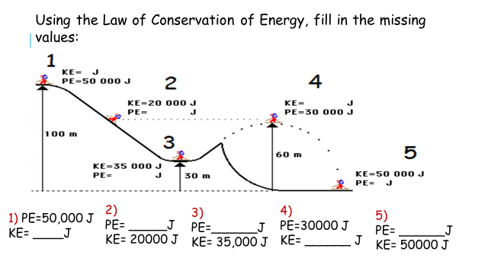
Create the following bracemap on a separate sheet of paper and fill it out as you rotate between stations:

