DO NOT WRITE ON THIS
Class Set #

_________
Investigation #4: Buggy Car Lab

Objectives

This investigation will give you an opportunity to:
- Determine the mathematical relationship between the distance and time for objects in motion using the battery-operated car.
- Define constant velocity.
- Determine and define the meaning of the slope.
- Create a position vs. time graph using collected data.
PRE-LAB
Focus Question: What will the shape of the distance vs. time graph look like for the battery-operated car?
Prediction: The shape of the graph for a distance vs. time graph for the battery-operated car will be ___________________________because ____________________________.
Predictive graph: Create a qualitative graph.
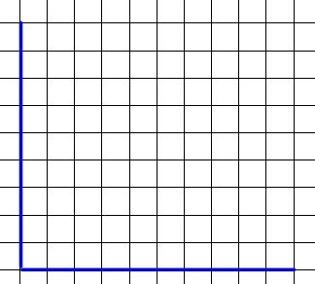
DURING LAB
Evidence:
Data Table: (If time permits do more than one trial and use the average time).
- Time (s) | - Distance (cm)
Graph: Use separate graph paper. Make a quantitative graph and be sure to include all the components of a good graph.
Find the equation: Use y=mx+b
Calculate Percent Error: (b value ÷ maximum y-value) x 100
POST-LAB
Use the following sentence stems to complete your CLAIM and REASONING using EVIDENCE from your graph and data.
Claim:
For every ___ second (s), the car travels ____ centimeter (cm).

Reasoning:
Based on my graph I know that my prediction was______________. The reason for this is because distance and time have _________ (direct/inverse) relationship. This means that if ____________________, then _______________________. The slope and the shape of the distance vs. time graph indicate that the buggy car is traveling at a ___________________ (changing/constant) speed because______________________________. Therefore, if the buggy car is traveling in a ________________ (straight/circular) path it is in a state of ____________ (static/dynamic) equilibrium.

What physical quantity is represented by the slope of the line?

List any factors that may have contributed to sources of error in this lab.

