DIRECTIONS: Determine if each of the following represents exponential growth or decay. Then state the y-intercept and identify the rate of growth or decay.

$1) f\left(x\right)=100∙{2.5}^{x}$ 2) $f\left(x\right)=10,200∙{(0.6)}^{x}$

GROWTH or DECAY (circle one) GROWTH or DECAY (circle one)

Y-Intercept: Y-Intercept:

Rate: Rate:

3) $f\left(x\right)=12,000{(0.7)}^{x}$ 4) $f\left(x\right)=450∙{(1.7)}^{x}$

GROWTH or DECAY (circle one) GROWTH or DECAY (circle one)

Y-Intercept: Y-Intercept:

Rate: Rate:

5) The population of Medway, Ohio, was 4,007 in 2000. It was expected to decrease by about 0.36% per year.
a) Write an exponential decay function to model this scenario.

b) Use your exponential decay function from part (a) to determine the approximate population of Medway in 2020.

DIRECTIONS: Find the amount in the account for the given principal, interest rate, time and compounding period.

6) P = 800, r = 6%, t = 9 years; compounded quarterly

7) P = 3,750, r = 3.5%, t = 20 years; compounded monthly

8) P = 2400, r = 5.25%, t = 12 years; compounded semi-annually

9) P = 1,500, r= 4.5%, t = 3 years; compounded daily

10) P = 1,000, r = 2.8%, t = 5 years; compounded continuously

11) P = 16,000, r = 4%, t = 25 years; compounded continuously

12) Steve invests $1,800 in an account that earns 3.7% annual interest, compounded continuously What is the value in the account after 10 years?

13) Micah invests $5,280 in an account that earns 4.2% interest compounded monthly. What is the value of the account after 8 years?

DIRECTIONS: Rewrite each equation in either exponential or logarithmic form.

14) $3^{8}=6,561$ | 15) $\log_{10}(\frac{1}{100})=-2$ | 16) $e^{-3}=0.0498$ | 17) $\log_{8}(64)=2$
18) $5^{0}=1$ | 19) $\ln\left(148.41\right)=5$ | 20) $7^{3}=343$ | 21) $\log_{2}\left(\frac{1}{32}\right)=-5$

DIRECTIONS: Solve each equation. Round answers to the nearest hundredth, if needed.

22) $\log_{3}\left(7x+6\right)=3$ 23) ${2.75e}^{x}=38.6$ 24) $3\ln\left(3x-1\right)=6$

25) ${10}^{x+1}-15=35$ 26) $1.5e^{2x}+3=30$ 27) $\log\left(x-3\right)=-3$

28) How long does it take for $250 to grow to $600 at 4% annual percentage rate compounded continuously. Round to the nearest year.

Sketch a graph of the following functions and then describe the key features. Make a table to help sketch the graph.

29) $y=\log_{5}(x)$  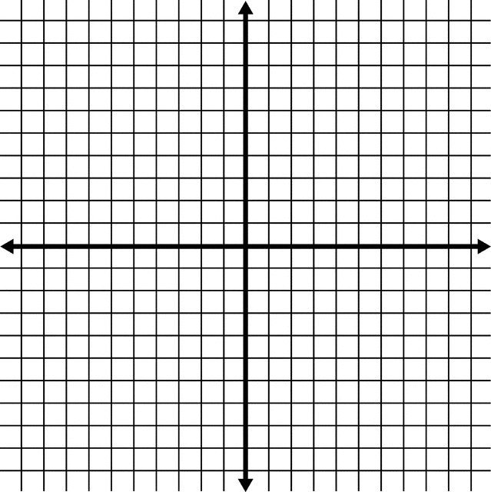  X Y  Domain:  Range:  Intercept:  Asymptote:  End Behavior: | 30) $y=\log_{2}\left(x+1\right)+3$  X Y  Domain:  Range:  Intercept:  Asymptote:  End Behavior:
DIRECTIONS: Find the equation of the inverse of each function.

31) $f\left(x\right)=5^{x-3}$ 32) $f\left(x\right)={\left(\frac{1}{2}\right)}^{x-1}$ 33) $f\left(x\right)=6^{x+7}$

34) $f\left(x\right)=\log_{2}(8x)$ 35) $f\left(x\right)=\ln\left(x+3\right)-1$ 36) $f\left(x\right)=4\log_{2}\left(x-3\right)+2$

37) How do you know if the graph of two functions are inverses of each other?

DIRECTIONS: Determine if the functions are inverses of each other. Explain your reasoning.

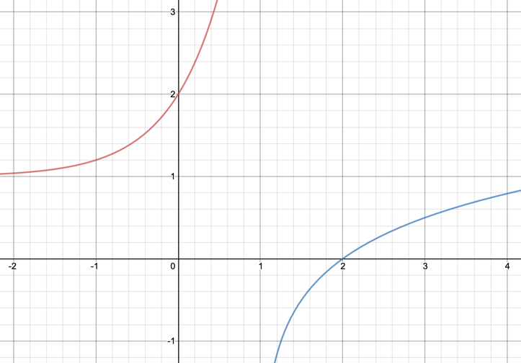  38) | 39)  