Name_________________________________________ #_______ Date__________________ Hour_______
Station #3: Patterns Uncover and Share Your Ideas
(20 point formative assessment)

Unit Essential Question:___________________________________________________________________
Lesson Question: How can we make accurate predictions?

Objectives:
- Students share their understandings of how interpreting data is used to make accurate predictions.
- Students examine patterns in data by comparing average monthly low temperatures and daylight hours for a specific city.

Uncover Your Ideas Directions: Follow the step-by-step directions below; answer all questions with a restate.

1. Make a prediction: What do you think the average temperature would look like across the United States?
________________________________________________________________________________________
________________________________________________________________________________________
2. Is the average temperature the same across the United States? YES NO MAYBE
3. Why does the average temperature the same across the United States change? _____________________
________________________________________________________________________________________
________________________________________________________________________________________
4. Turn your prediction into a hypothesis: If _____________________________________________________,
then____________________________________________________________________________________.
_____teacher-check in; ask for the data tables.
5. Get one of the Average Monthly Temperature & Daylight data sets from your group leader; notice that they are all different.
6. You will use the template on the next page to construct a graph from your data table.
7. Use this checklist to make sure that you include all of the necessary components of a graph:
_____ title
_____ x-axis label
_____ y-axis label
_____ x-axis scale
_____ y-axis scale
_____ a key
_____ two different colored pencils/markers to show the difference between Average low temperature (ºF) and Average daylight (hour

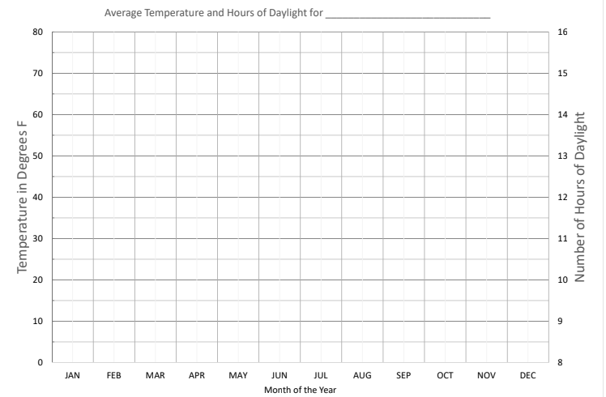
_____teacher-check in
Share your Ideas Part I Directions: Answer the following questions using complete sentences with a restate.
1. Describe the pattern you notice for average low temperature from the beginning to the end of the year:
________________________________________________________________________________________
________________________________________________________________________________________
2. Describe the pattern you noticed for average hours of daylight from the beginning to the end of the year:
________________________________________________________________________________________
________________________________________________________________________________________
3. How might these patterns be related?________________________________________________________
________________________________________________________________________________________
________________________________________________________________________________________
4. Do you think the yearly average temperature graph of Detroit, MI will be similar to that of Miami, FL? Explain:
________________________________________________________________________________________
________________________________________________________________________________________
________________________________________________________________________________________

