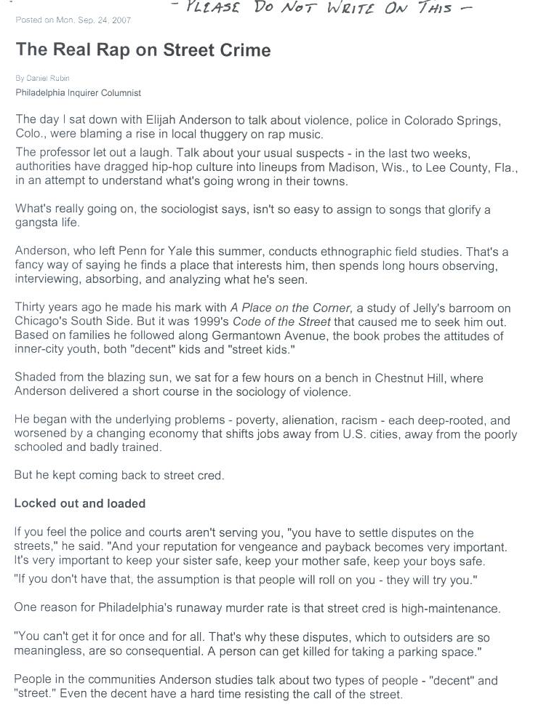

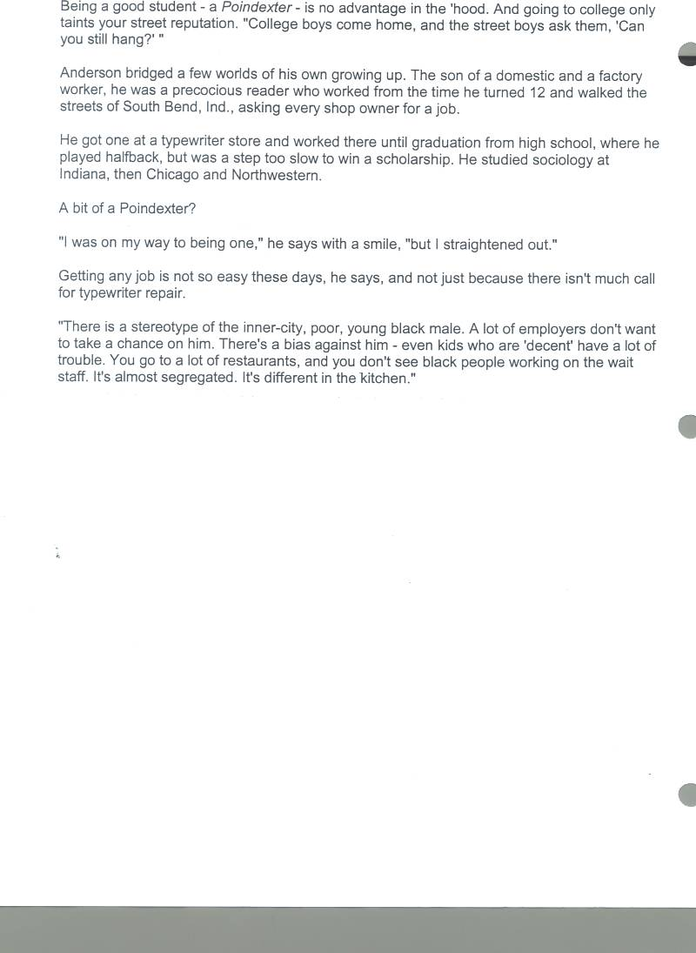

Ch. 2, Section 2 Cultural Variations – Subcultures
“The Real Rap on Street Crime”

Directions: Please answer on a separate sheet of paper.

- Why might a sociologist say that high-crime neighborhoods in Philadelphia have developed into a subculture or possibly even a counterculture?

- In what specific ways are the components of this inner-city culture different from “American” culture? (think about: technology, symbols, language, values, norms)

- Explain why the problem of inner-city crime in Philadelphia does not have an easy solution.

