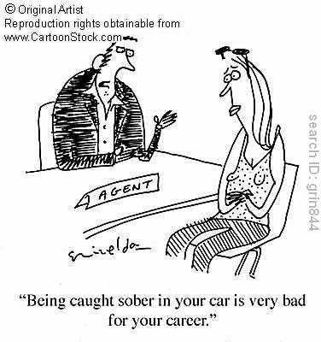
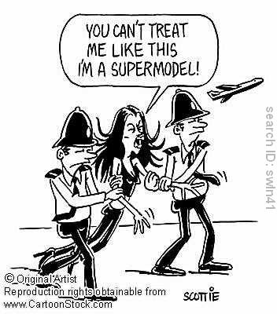

Questions to analyze:

- What American subculture is being mocked in the two cartoons?
- In the 1st cartoon on the left, why do you think the agent is saying that?
- What does the message of the 1st cartoon say about the norms and values of that subculture?
- What message is the artist trying to pass along in the 2nd cartoon?
- What do you think the artists’ opinions of these subcultures are? How can you tell?

