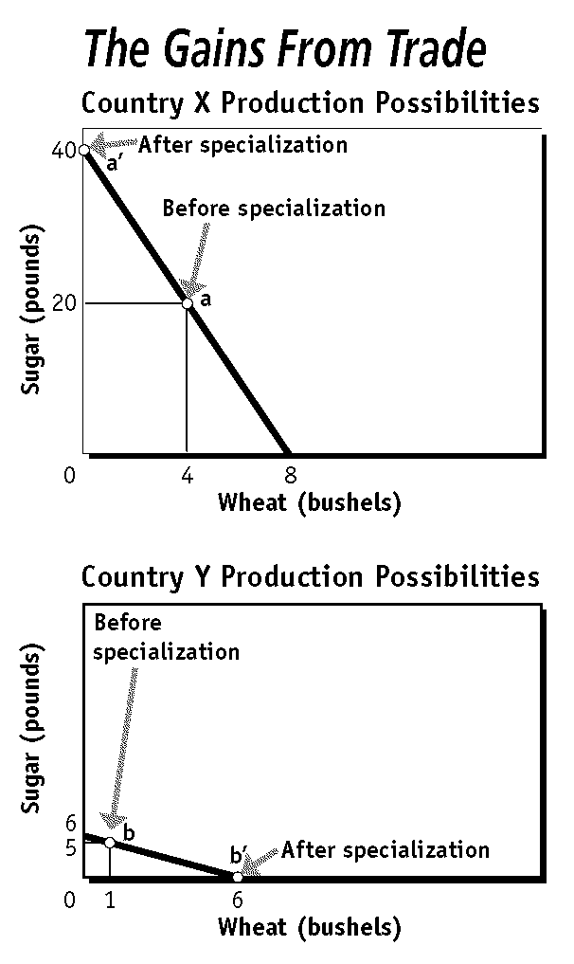 | Based upon the graphs:  - What is the total wheat production before specialization?  - What is the total wheat production after specialization?  - Did wheat production increase or decrease after specialization? By how much?  - Based upon your answer to #3, what can you conclude about specialization?  - Which country has an absolute advantage in wheat production? By how much?  - Which country has a comparative advantage in wheat production? Show work.

Smoot –Hawley Tariff Act (3 facts)
Weak dollar (3 facts)
Strong Dollar (3 facts)
absolute advantage (examples)
comparative advantage (examples)

Definitions & Applications
absolute advantage
comparative advantage
exports
foreign exchange
imports
infant industries
North American Free Trade Agreement
outsourcing

protectionists
protective tariff
quota
reciprocal trade agreements
revenue tariff
trade deficit
trade surplus
World Trade Organization (WTO)

