Section 7-3 Similar Triangles

Similar Triangle Theorems:
Postulate: | Example: | Practice with Hidden Tools:
AA:  If two angles of one triangle are congruent to two angles of another triangle, then the two triangles are ___________________ | 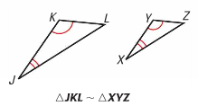 | ∆SVR and ∆UVT  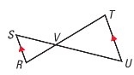
SSS:  If the corresponding side lengths of two triangles are _____________________ then the triangles are similar | 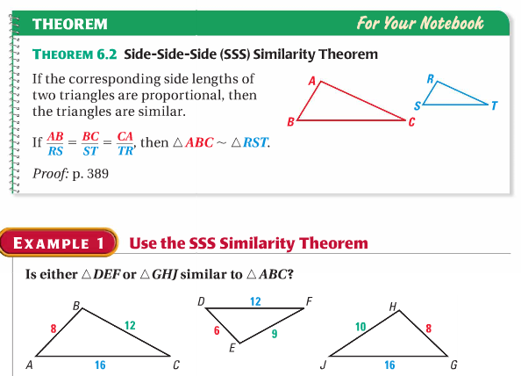 | ∆RQU and ∆SQU
SAS:  If an angle of one triangle is congruent to an angle of a second triangle and the lengths of the sides including these angles are _______________, then the triangles are similar. | 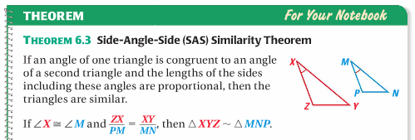 | 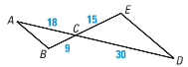  Match order!!

